Blue/Gold Star Memorial Markers
In 1946 the National Garden Clubs embarked on its first nationwide project. Known as the Blue Star Memorial program, affiliated garden clubs across the country began erecting memorial plaques surrounded by attractive planting material along designated highways in honor of the Armed Forces of the United States of America. Over the last 70 years more than 3,000 Blue Star Memorial markers have been dedicated across the country. The first Blue Star Memorial marker in the state was placed at the foot of US 1 in Key West in 1949. Since then more than 200 Blue/Gold Star Memorial markers of the three authorized types have been dedicated in Florida along highways, at veteran’s centers, at parks, at national cemeteries, and at many other civic locations.

For more information about the program or the markers themselves, contact the Florida Federation of Garden Clubs Blue/Gold Star Memorial Chairman.

The following lists the markers acquired by FFGC District:

District I – (Counties: Escambia, Santa Rosa, Okaloosa and Walton)

Acquisition/
Dedication Type/
Date Club Location Status Photo

1 | 4/28/1958 | Pensacola Federation of Garden Clubs | Originally at Florida Welcome Center on US 90 near FL/AL state line | Highway Marker moved to the I-10 Welcome Center 10/86; but now missing and presumed lost | 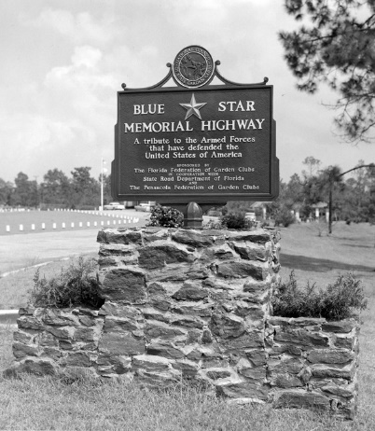
2 | 4/25/1960 | Milton Garden Club | Median of US 90 just east of Stewart St.  In Milton | Highway Marker  Re-furbished and re-dedicated 5/17/2014 | 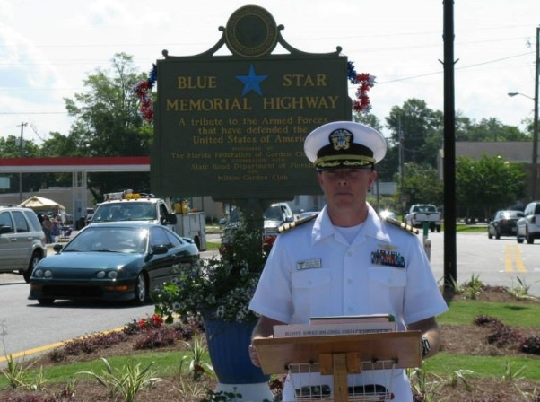
3 | 10/31/1960 | Eglin Officers' Wives Garden Club & Gulf Area Garden Club (both no longer in FFGC) | Along US 98 adjacent to Indian Mound Museum in Ft. Walton Beach | Highway Marker adopted by Garnier Beach GC and the museum (re- furbished in 2018) | 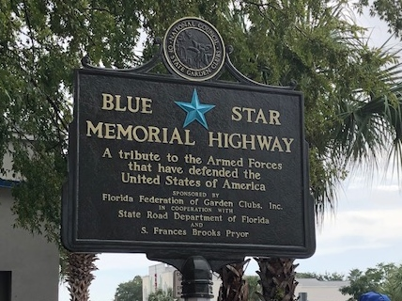
4 | 4/29/68 | Dogwood and Crestview Garden Clubs | Located on SR 85 near corner with S. Main St.,  Crestview  (Originally was on US 90) | Highway Marker Restored by Dogwood GC and re-dedicated 9/22/2016 | 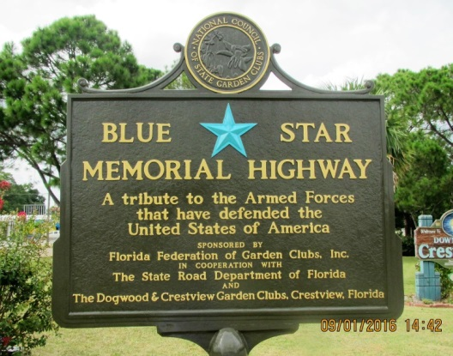
5 | 6/3/69 | Pensacola Federation of Garden Clubs | Along US 98 at base of  Bay Bridge and later re-located to the 5 Flags Triangle at Bayfront Parkway and Gregory St., Pensacola | Highway Marker - Missing and presumed lost (vintage newspaper photo taken at 1969 dedication) | 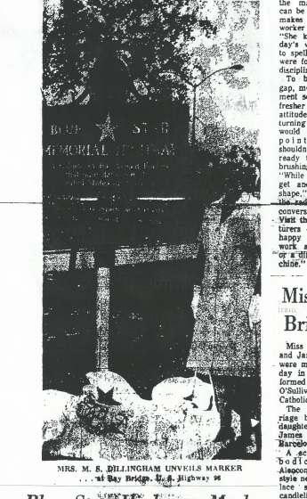
6 | 11/15/74 | Amaryllis Garden Club of the Pensacola Federation  (club no longer in FFGC) | In median of Garden Street near intersection with A Street, Pensacola | Highway Marker | 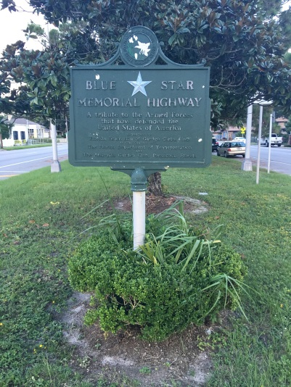
7 | 8/19/76 | Military Officers’ Wives -Oleander Garden Club of the Pensacola Federation | Along US 98 in front of Naval Hospital grounds, Pensacola | Highway Marker | 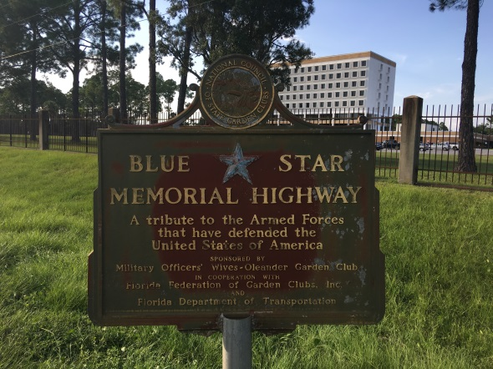
8 | 4/15/77 | Green Thumb Garden Club of Santa Rosa Beach | Near northeast corner of US 98 and US331, Santa Rosa Beach | Highway Marker | 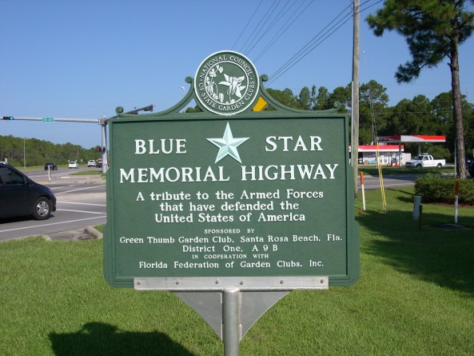
9 | 4/15/77 | DeFuniak Springs Garden Club | In Wayside Park on US 90 at US 331. DeFuniak Springs | Highway Marker | 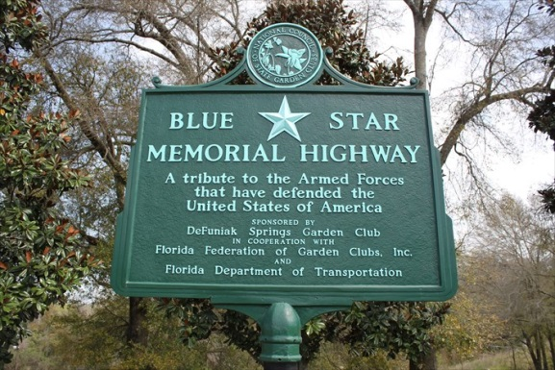
10 | 9/29/06 | Pensacola Federation of Garden Clubs | In Veterans Memorial Park at East Ramona & Bayfront Parkway, Pensacola | Highway Marker | 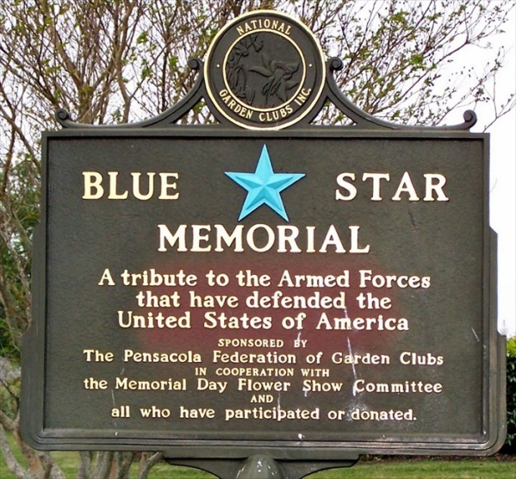
11 | 2/17/14 | Garnier Beach Garden Club | On wall of breezeway along west side of Fort Walton Beach Library, 185 Miracle Strip Pkwy. SE | By-Way Marker | 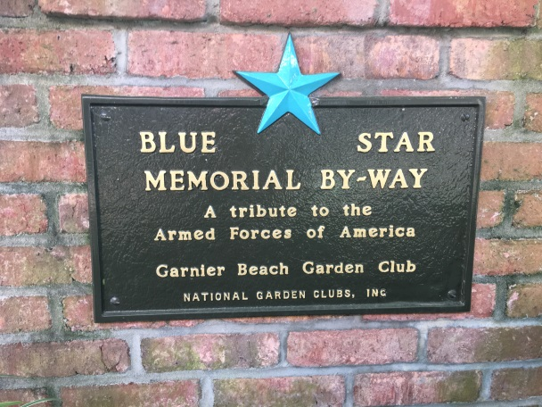
12 | 5/16/14 | Navarre Garden Club | Along US 98 at Navarre Park Tourist Info Center, Navarre | Highway Marker | 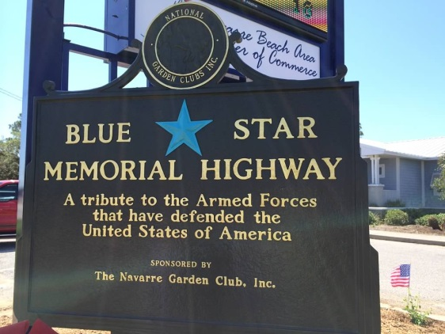
13 | 6/1/16 | Garnier Beach Garden Club | Along Bud & Dorie Day Patriot’s Trail about 100 yards west of Iowa Dr. & north of California Dr., Fort Walton Beach | By-Way Marker | 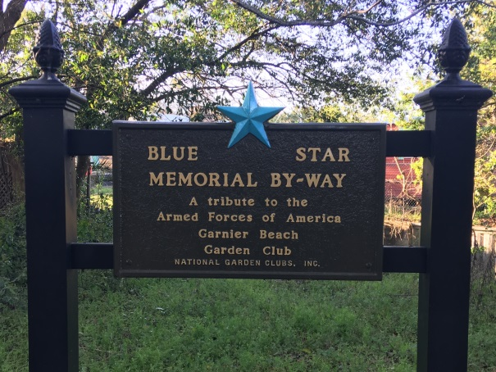
14 | 2/17/14 | The Garden Clubs of District I | Located in Barrancas National Cemetery at Pensacola Naval Air Station | Memorial Marker | 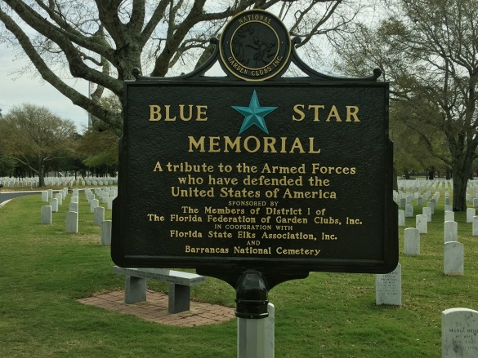
15 | 3/21/18 | Garnier Beach Garden Club | In front of Gates Center Bldg. at Air Force Enlisted Village, 92 Sunset Lane, Shalimar | By-Way Marker | 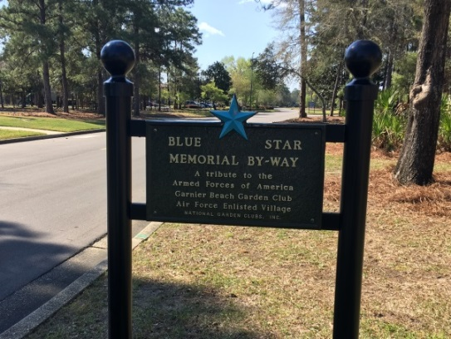
16 | 11/18/19 | Milton Garden Club | To be located along SR 87, Milton | Highway Marker | 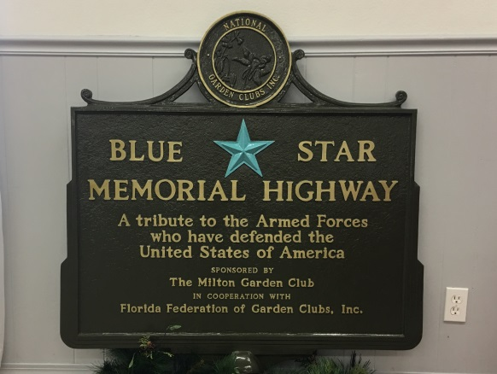
17 | 10/11/22 | Destin Garden Club | Destin Library, 150 Sibert Avenue, Destin | By-Way Marker | 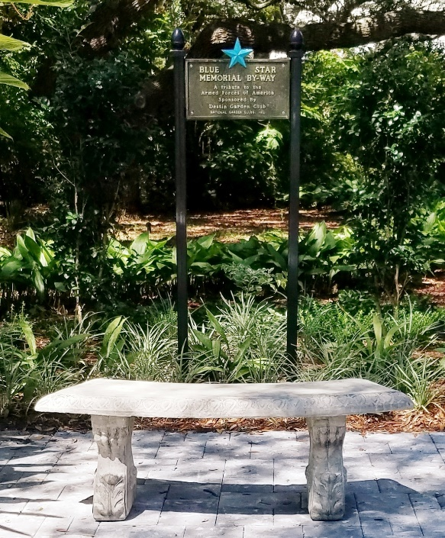

District II – (Counties: Holmes, Washington, Jackson, Bay, Calhoun, Gulf, Liberty and Gadsden)

1 | 11/3/1958 | Quincy Garden Club | Along north side of US 90,  At east entrance to Quincy | Highway Marker; missing and presumed lost | 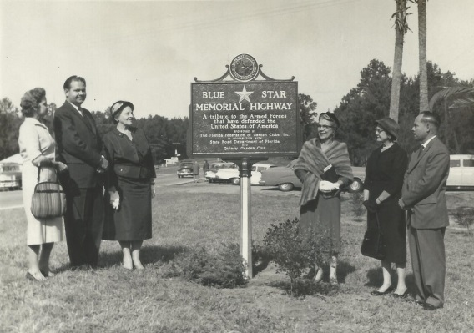
2 | 11/3/1958 | Marianna Garden Club | along US 90 at east end of Constitution Lane in downtown, Marianna | Highway Marker | 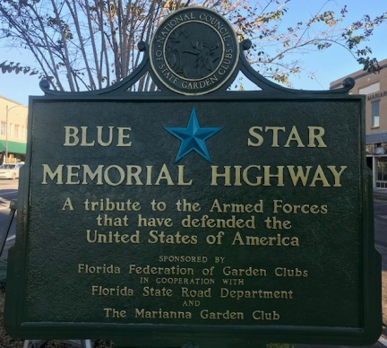
3 | 4/20/1959 | Chattahoochee Garden Club | Along US 90 east of Apalachicola River Bridge, in front of Hardees at 651 W. Washington St. Chattahoochee | Highway Marker – orphaned – club no longer in FFGC | 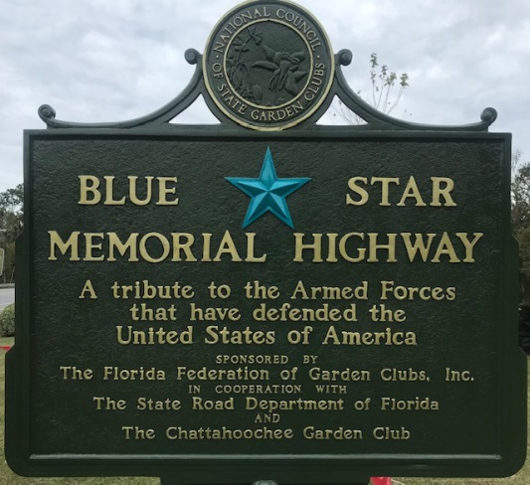
4 | 10/28/1960 | Cottondale Garden Club | Along US 90 just west of RR overpass on south side (west of US 231 intersection), Cottondale | Highway Marker – orphaned – club no longer in FFGC | 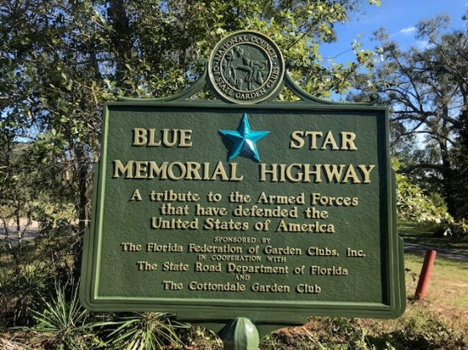
5 | 4/26/1961 | Chipley  Garden Club | Along US 90  in front of FDOT on north side just west of the Design Building, Chipley | Highway Marker | 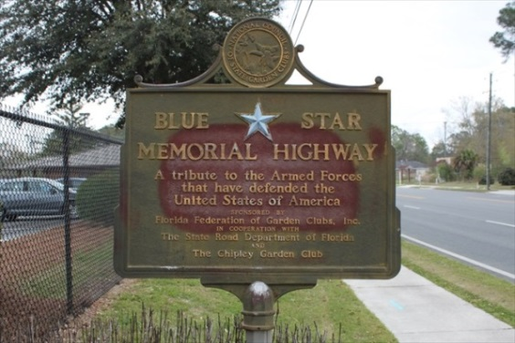
6 | 4/29/1962 | Bonifay Garden Club | Along US 90 opposite Armstrong Street, Bonifay | Highway Marker | 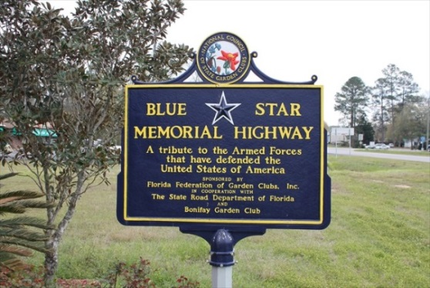
7 | 5/1/1962 | Port St. Joe Garden Club | Along US 98 between Allen Memorial Way & Gautier Memorial Lane, Port St. Joe | Highway Marker | 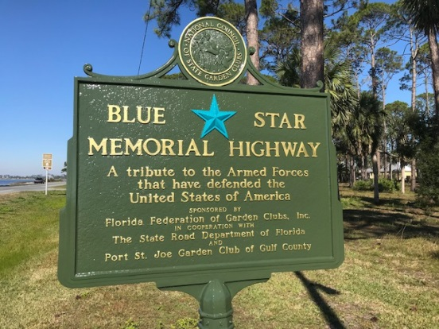
8 | 11/2/1962 | Gulf Beach Garden Club | On SR 30 at intersection of SR 79, Panama City Beach | Highway Marker | 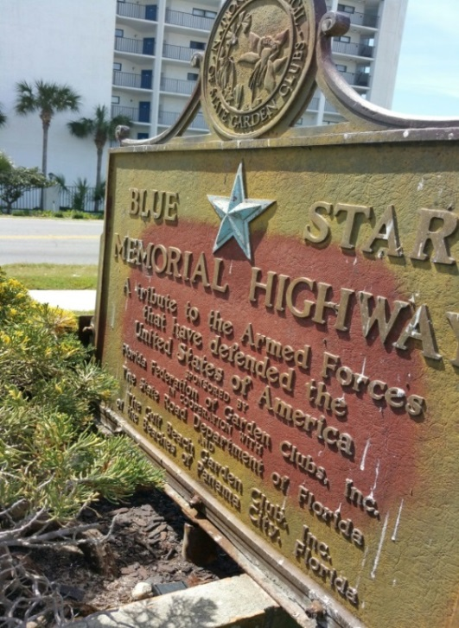
9 | 4/29/1968 | Panama City  Garden Club | Along US 98 (15th St.) at intersection with US 231 west of Harrison St., Panama City | Highway Marker (1968 marker replaced in 2003) | 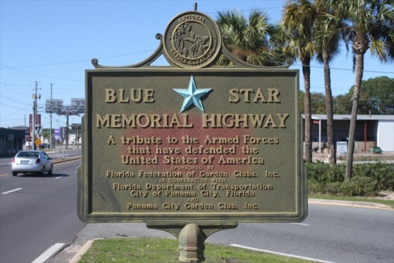
10 | 4/17/1971 | Panama City  Garden Club | Along US 98 at Tyndall Airforce Base just north of Tyndall Drive gate, Panama City | Highway Marker | 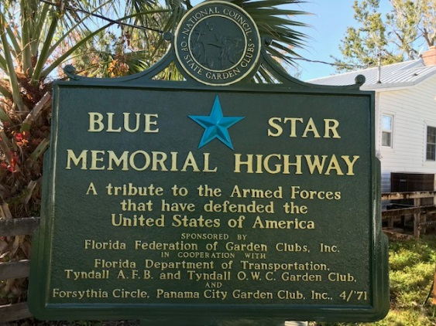
11 | 10/26/1972 | Parker  Garden Club | Along US 98 and W. Cooper Dr. just east of the Dupont bridge, Parker | Highway Marker – orphaned – club no longer in FFGC | 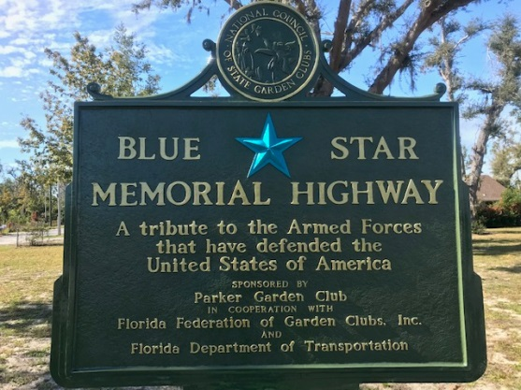
12 | 8/26/2011 | Wausau Garden Club | Along S.R. 77 at Glen Avenue, Wausau (currently located at NW corner of property across from the Town Hall) | Highway Marker – | 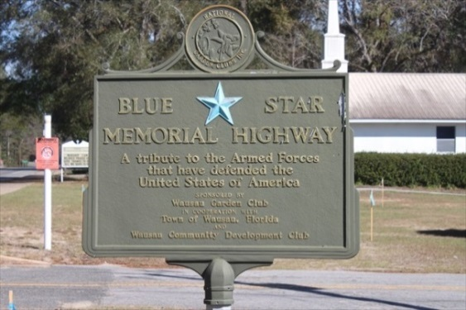
13 | 7/11/2014 | Sneads Carlisle Rose Garden Club | Along US 90 at Green Ave., Sneads | Highway Marker | 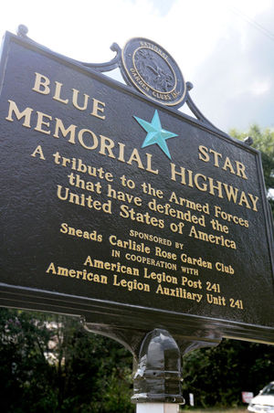
14 | 5/16/2016 | Graceville Garden Club | S.R. 77 at southern city limits, Graceville | Highway Marker | 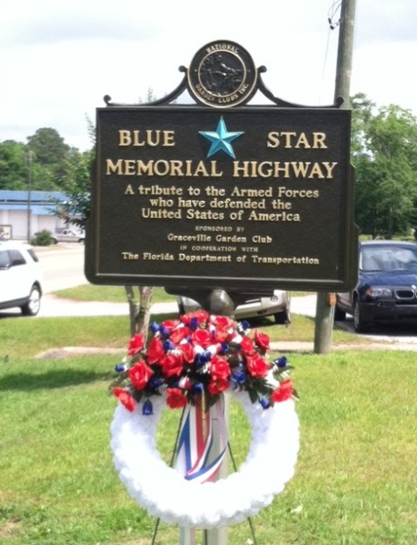
District III – (Counties: Franklin, Wakulla, Leon, Jefferson, Madison, Taylor, Hamilton, Suwannee and Lafayette)

1 | 3/12/1959 | Tallahassee Garden Club | Along US 90 (Mahan Drive) near old Veterans Admin. Clinic building, Tallahassee | Highway marker | 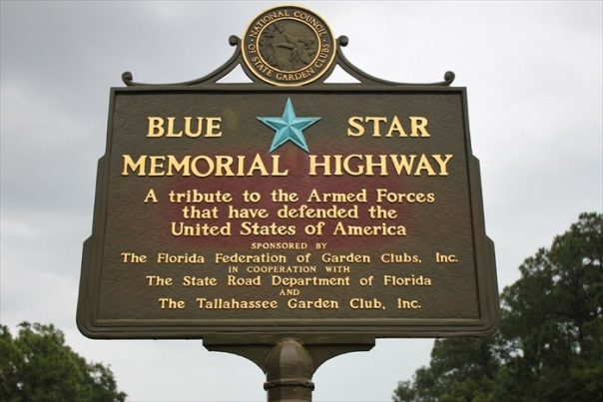
2 | 10/26/1960 | Perry and Lantana Garden Clubs | in median of US 19/98 just south of entrance to Forest Capital Museum State Park, Perry | Highway marker | 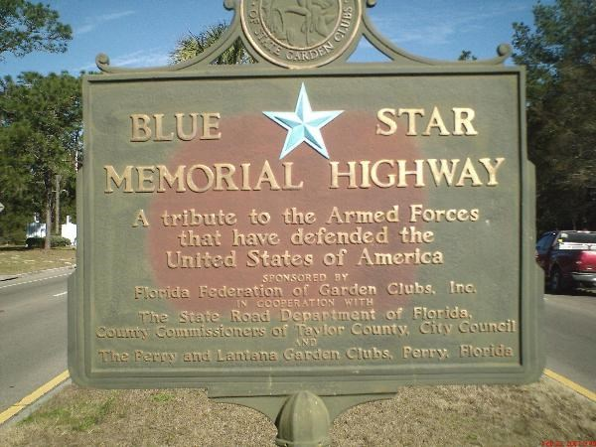
3 | 1/17/77 | Tallahassee Garden Club | Along US 27 in median near S. Calhoun St. in front of capitol building, Tallahassee | Highway Marker | 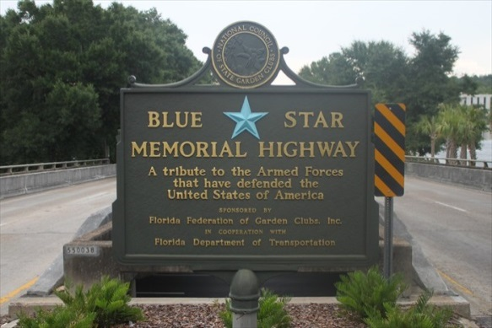
4 | 4/30/77 | Yaupon Garden Club | Along US 98, in Veterans Memorial Park, Carrabelle | Highway Marker – orphaned – club no longer in FFGC | 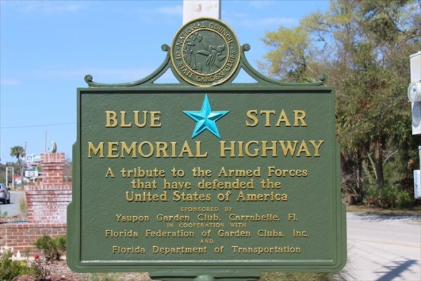
5 | 4/8/2000 | Madison  Garden Club | Along US 90 at Shelby St. near Four Freedoms Monument, Madison | Highway Marker | 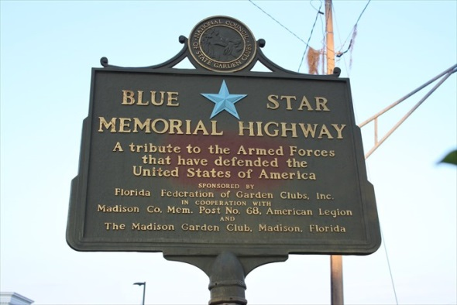
6 | 11/2/2001 | Live Oak Garden Club | In small park at US 90 W, Pine St. and Warren St., Live Oak | Memorial Marker | 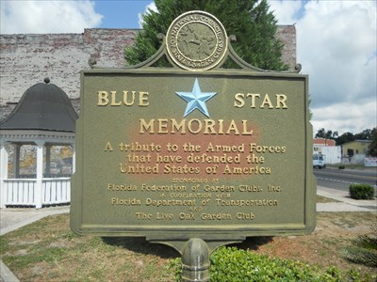
7 | 4/26/2010 | Perry Garden Club | In median of US 19/98 near W. Julia Street north of Perry | Highway Marker | 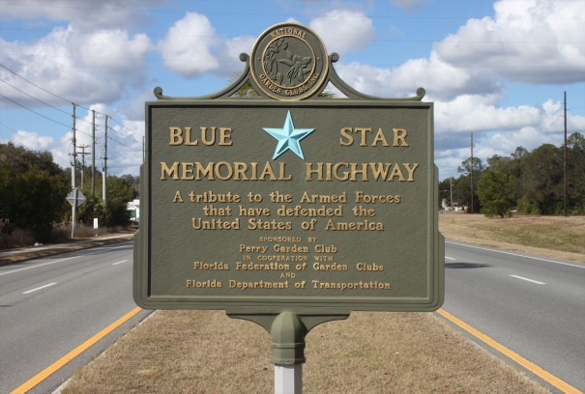
8 | 3/9/2017 | Garden Clubs of District III | Just inside entrance to Tallahassee National Cemetery at 5015 Apalachee Parkway, Tallahassee | Memorial Marker | 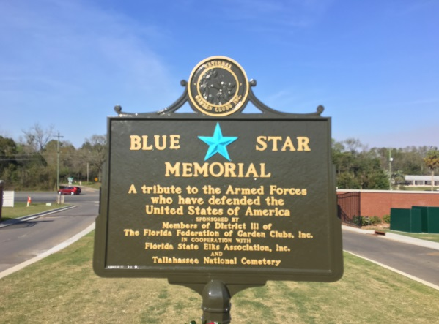
9 | 4/14/2018 | Steinhatchee  Garden Club | located in front of the Community Center at 1013 S. Riverside Drive, Steinhatchee | By-Way Marker | 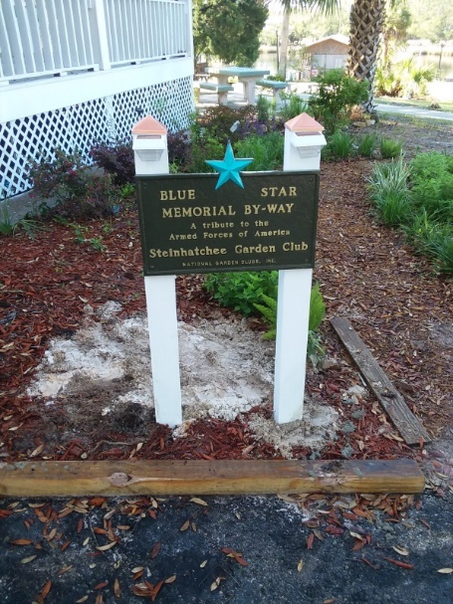

District IV – (Counties: Baker, Union, Nassau, Duval, Clay, St. Johns and Putnam)

1 | 3/17/50 | St. Augustine Garden Club | Along US 1 in front of #1 St. Johns Medical Park Drive just north of Old Moultrie Road, St. Augustine | Highway marker | 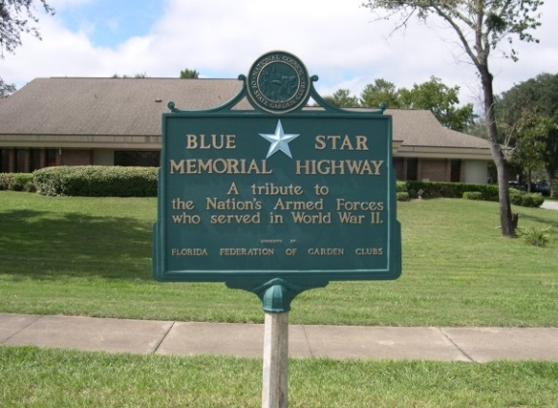
2 | 11/28/52 | Garden Club of Jacksonville | In median of US 1 just south of the Florida and Georgia state line | Highway marker missing and presumed lost | 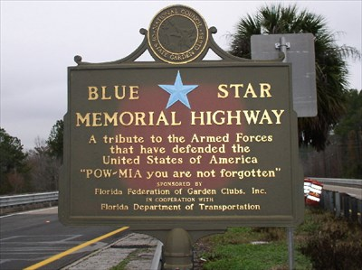
3 | 6/18/60 | Ribault Garden Club | Located in Pablo Historical Park just off US 90, Jacksonville Beach | Highway Marker (originally located on US 90 east of B.B. McCormack Bridge) | 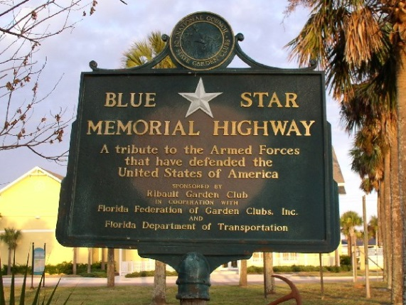
4 | 9/22/60 | Garden Club of Jacksonville | In median of US 17 south of Park Street in Avondale neighborhood of Jacksonville | Highway Marker (originally located on US 90 at FHP Station near Marietta) | 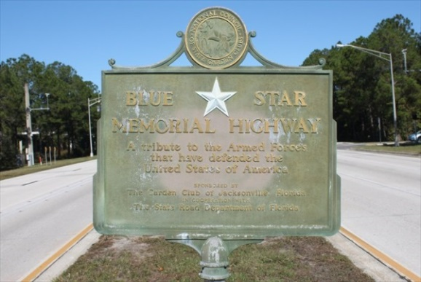
5 | 12/19/64 | Glynlea Circle of the Garden Club of Jacksonville (marker adopted by the Ribault Garden Club) | Along US 90 near Fort San Nicholas in the St. Nicholas neighborhood of Jacksonville | Highway Marker; reported missing & presumed lost | 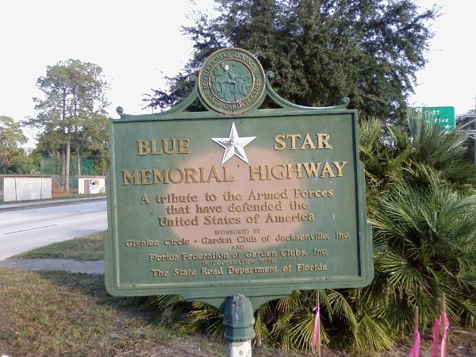
6 | 4/4/69 | Garden Club of Orange Park | In median of US 17 near Dog Track (455 Park Ave.), Orange Park | Highway Marker | 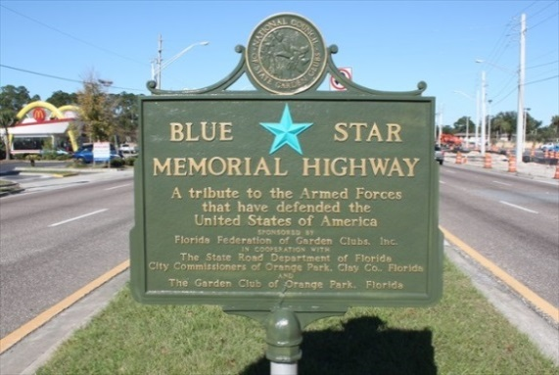
7 | 3/7/72 | Ortega Circle of the Garden Club of Jacksonville | Along US 17, near intersection with Ortega Blvd. in Ortega neighborhood of Jacksonville | Highway Marker | 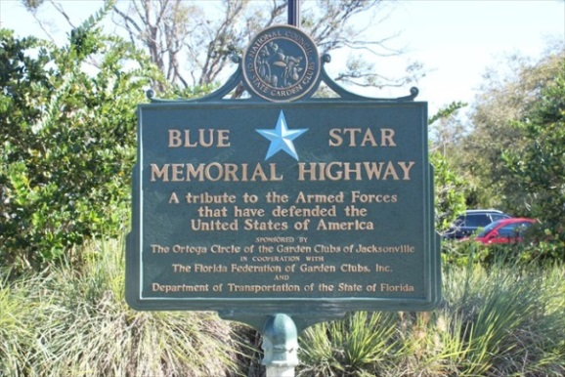
8 | 12/14/74 | Mountain Laurel Circle of the Garden Club  of Palatka | Along US 17 near the intersection with SR 207 in East Palatka | Highway Marker | 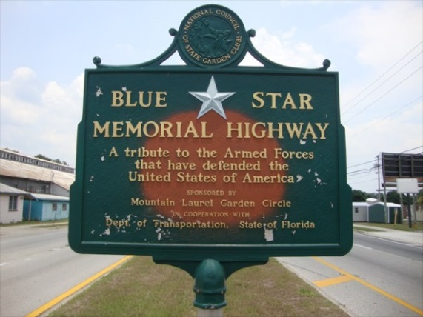
9 | 12/14/74 | Garden Club  of Palatka | Along US 17 at the intersection with SR 100 in Palatka | Highway Marker | 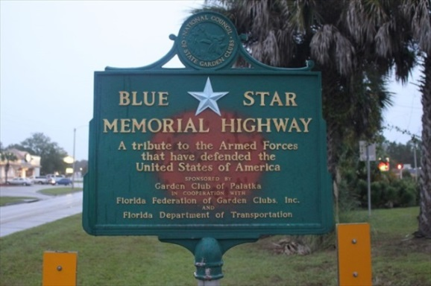
10 | 3/15/88 | Garden Club of Orange Park | In Magnolia Cemetery near entrance at 1040 Kingsley Ave., Orange Park | By-Way Marker | 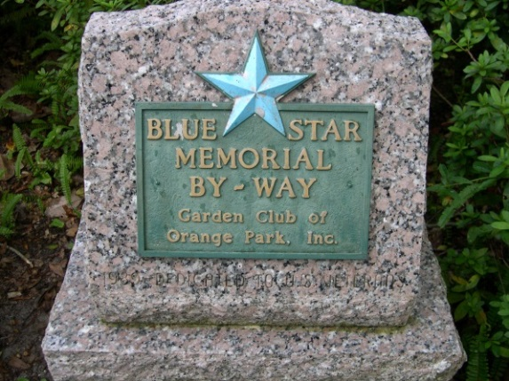
11 | 3/29/2012 | Garden Club of the Lakes | Along SR 100 across from 251 E. Walker Drive, Keystone Heights | Highway Marker | 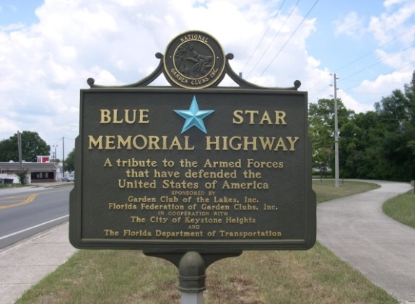
12 | 4/20/2012 | Garden Club of Hilliard | Along east side of US 1 in Hilliard | Highway Marker | 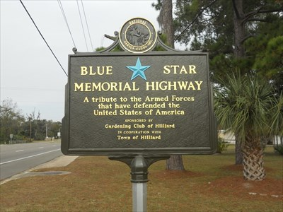
13 | 1/25/2015 | Garden Clubs of District IV | Near entrance of Jacksonville National Cemetery, 4083 Lannie Road, Jacksonville | Memorial Marker | 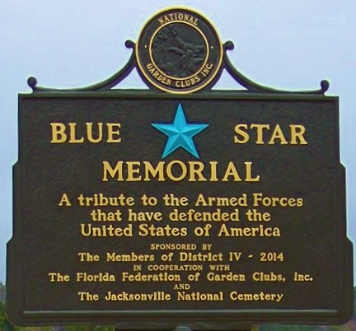
14 | 2/16/2015 | Garden Club of Green Cove Springs | At Veterans Triangle, 915 Walnut St, Green Cove Springs | By-Way Marker | 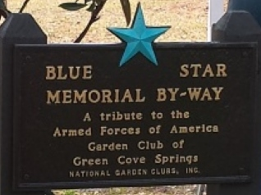
15 | 3/18/2017 | Garden Clubs of District IV | In St. Augustine National Cemetery, 104 Marine Street, St. Augustine | Memorial Marker | 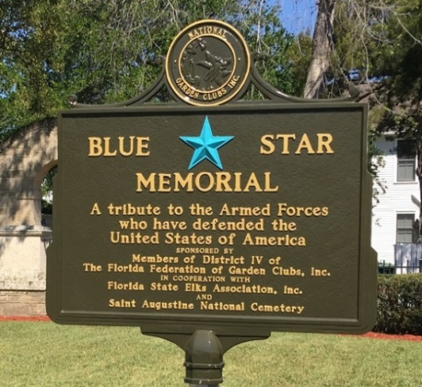
16 | 4/20/2018 | Garden Club of Fleming Island | In front of the Clay County Library Headquarters located at 1895 Town Center Blvd.,  Fleming Island | By-Way Marker | 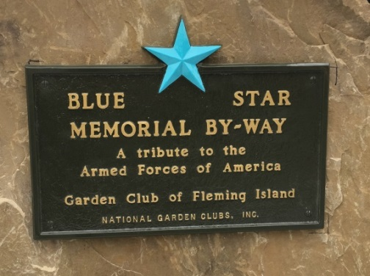
17 | 2/27/2021 | Garden Clubs of District IV | at POW-MIA Memorial, 6112 POW-MIA Memorial Pkwy., Jacksonville | Gold Star Families Memorial Marker | 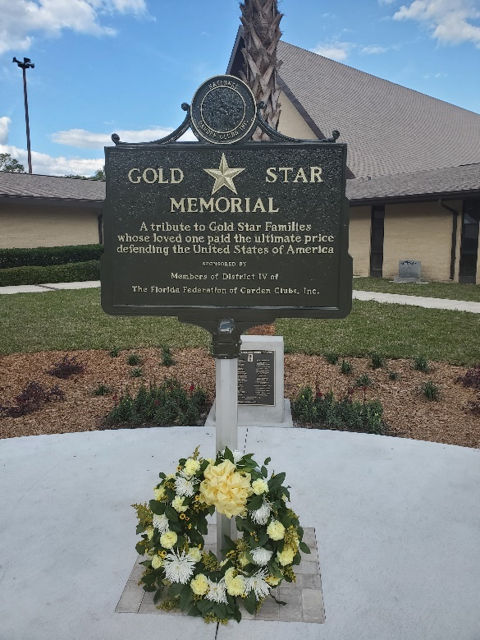
18 | 5/21/2022 | Garden Clubs of Middleburg | Middleburg Clay Hill Library, 2245 Aster Avenue, Middleburg | By-Way Marker | 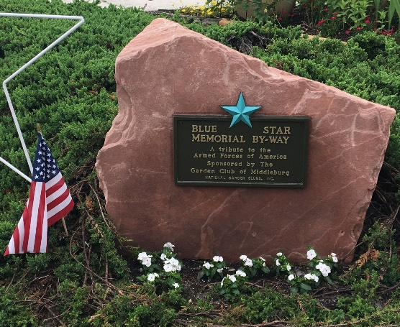

District V – (Counties: Columbia, Dixie, Gilchrist, Bradford, Alachua, Citrus, Hernando, Levy and Marion)

1 | 1/21/71 | Garden Clubs of District V | Along US 41 at entrance of Rainbow Springs State Park, north of Dunnellon | Highway Marker | 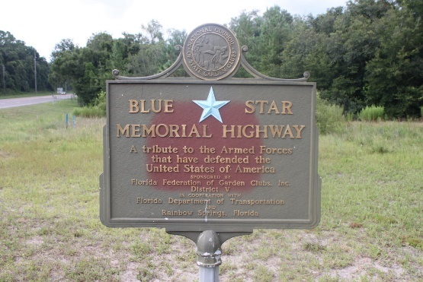
2 | 5/17/72 | Lake City Garden Club | Along US 90 in Lake City | Highway Marker missing and presumed lost | 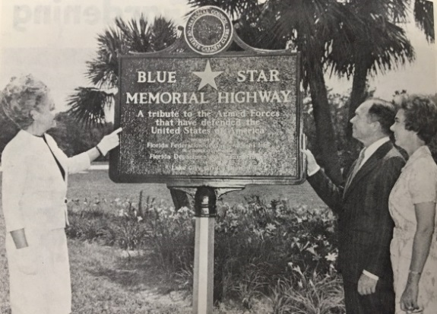
3 | 5/20/2005 | Garden Club  of Crystal River | Along US19/98, across from Crystal River Mall | Highway Marker | 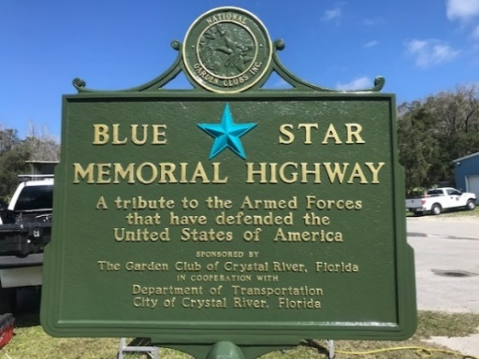
4 | 1/5/2007 | Four Seasons Garden Club | Located at 1601 SW Archer Rd (SR 24) & VA Medical Complex, SW 16th St., Gainesville | Highway Marker | 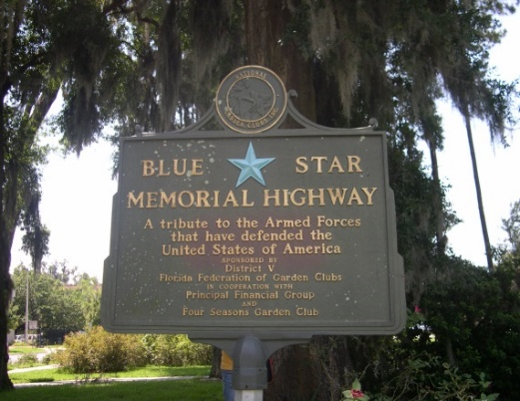
5 | 1/20/2007 | Lake City Garden Club | Located at VA Medical Center US441 at 619 S. Marion Ave., Lake City | Highway Marker | 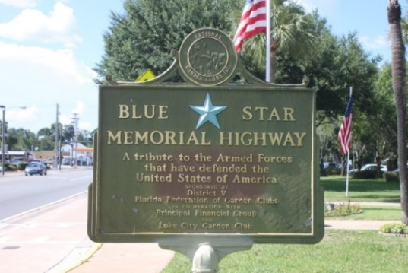
6 | 1/20/2007 | Belleview Garden Club | Located at Belleview City Hall grounds along US 441,  Belleview | Highway Marker | 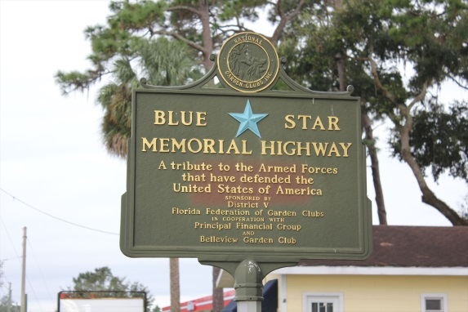
7 | 1/30/2008 | McIntosh Seedlings Garden Club | Along US 441 on city property at southern entrance to McIntosh | Highway Marker | 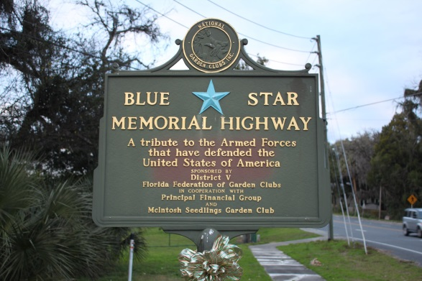
8 | 6/20/2009 | Four Seasons Garden Club | Located along US441 at turnoff to historic Micanopy | Highway Marker | 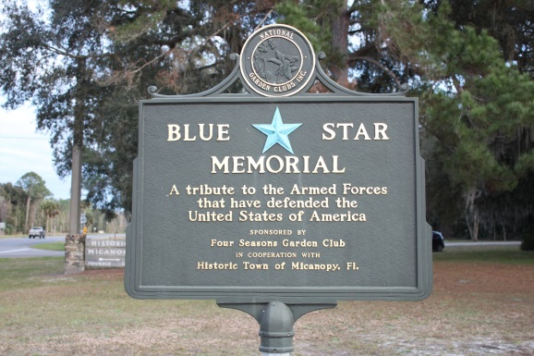
9 | 2011 | Garden Clubs of District V | Located at Paynes Prairie Rest Area on I-75 south of Gainesville | Memorial Marker | 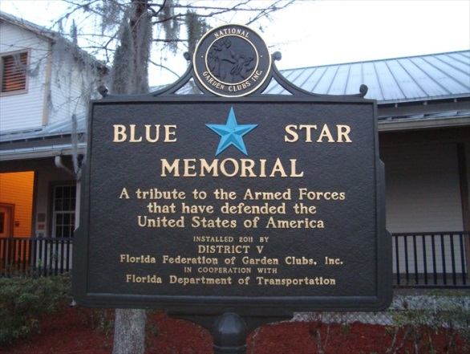
10 | 6/14/2016 | Floral City Garden Club | Located in Town Center Park, Floral City | By-Way Marker | 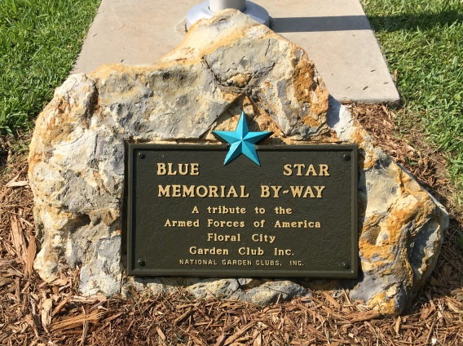
11 | 4/1/2017 | Homosassa River  Garden Club | Located in Stage Stand Cemetery, 4571 South Suncoast Blvd., Homosassa | Memorial Marker | 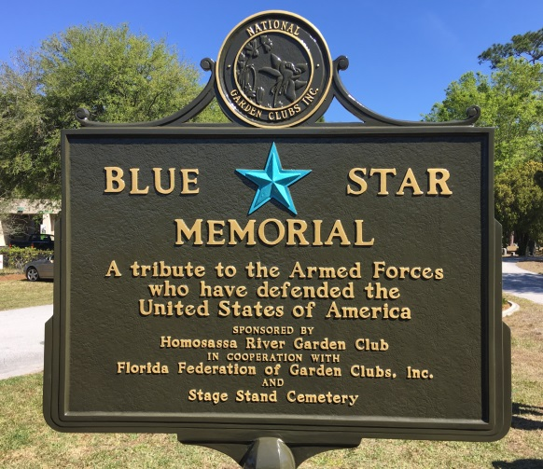
12 | 4/15/2017 | Garden Clubs of Districts V & VII | Located just inside entrance to the Florida National Cemetery, 6502 SW 102nd Ave., Bushnell | Memorial Marker | 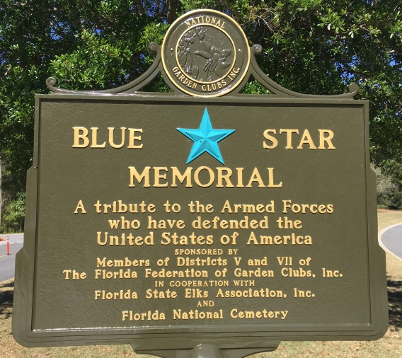
13 | 11/4/2017 | Gainesville Garden Club | Located in Kanapaha Veterans Memorial Park, Gainesville | Memorial Marker | 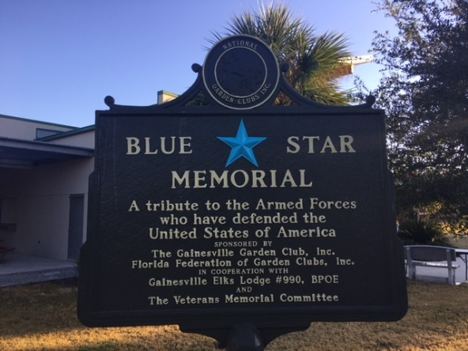
14 | 10/20/2018 | Gainesville Garden Club | Located at 1601 SW Archer Rd (SR 24) & VA Medical Complex, Gainesville | Gold Star Families Memorial Marker | 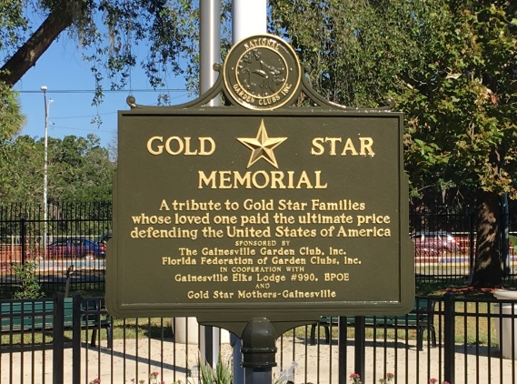

District VI – (Counties: Flagler, Volusia and Brevard)

1 | 4/25/1951 | Cocoa- Rockledge Garden Club | Along US 1 near intersection with So. end of Florida Ave., Rockledge | Highway Marker | 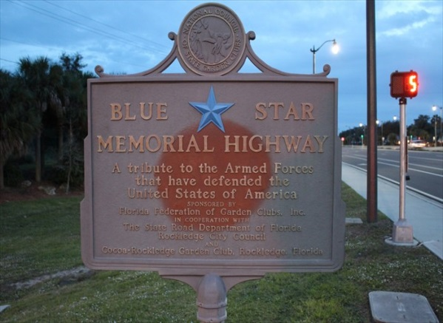
2 | 4/25/1951 | Eau Gallie Garden Club | Along the east side of Harbor City Blvd. (US 1) south of Sunset Drive in Melbourne | Highway Marker – orphaned – club no longer in FFGC | 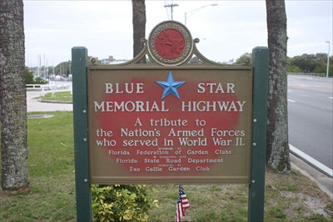
3 | 4/25/1951 | Melbourne Garden Club | In grassy triangle along US 1 at Tangerine Street near Florida Power & Light Ice Plant, 1604 S. Harbor City Blvd., Melbourne | Highway Marker | 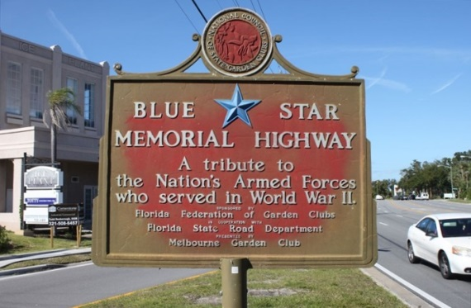
4 | 5/30/1953 | Originally Daytona Beach Garden Club  but now Council of Halifax District Garden Clubs | Located along US 1 in median of 900 block South near Fremont Street, Daytona Beach | Highway Marker  (original marker replaced with new marker in 2004) | 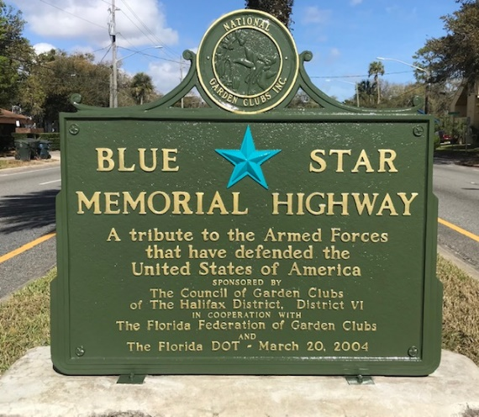
5 | 4/6/1960 | Garden Club of Deland | Located on US 92 near where U.S. 92 separates from U.S. Highway 17 between Deland and Daytona Beach | Highway Marker  (refurbished and rededicated 12/7/2011) | 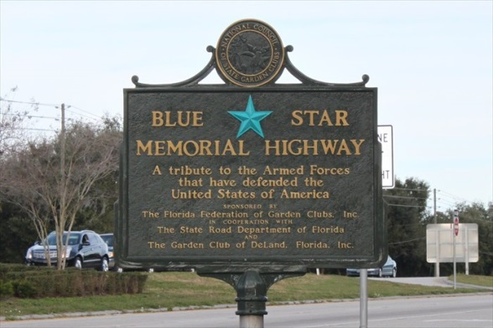
6 | 10/2/1964 | New Smyrna Beach Garden Club | Along median of US1 (near Dairy Queen at 729 N. Dixie Freeway), New Smyrna Beach | Highway Marker | 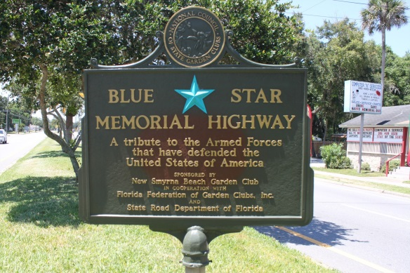
7 | 5/11/1965 | Titusville Garden Club | Along median of US 1 just north of Harrison Street, Titusville | Highway Marker | 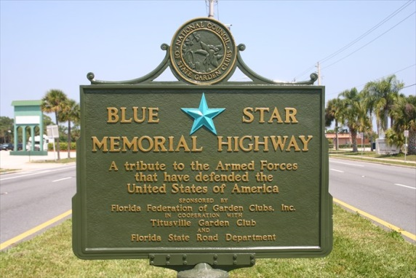
8 | 3/1/1969 | Port Malabar Garden Club | Removed from US 1 and now displayed at Valkaria Gardens Nursery at 8205 Babcock St. SE, Palm Bay | Highway Marker – orphaned | 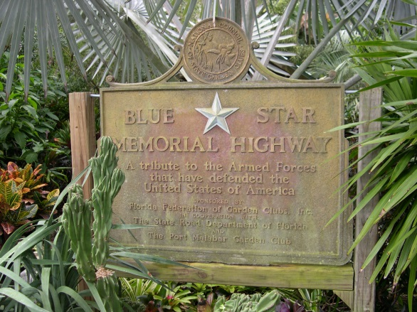
9 | 10/6/2006 | The Garden Clubs of District VI  (maintained by Garden Club at Palm Coast) | Located in front of entry to Palm Coast H. S. (Bulldog Drive and SR 100), Palm Coast | Highway Marker | 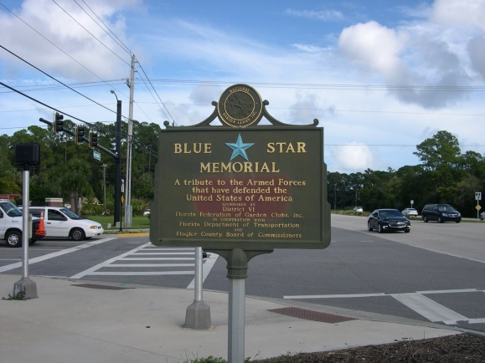
10 | 5/26/2008 | Deltona Garden Club | Located in Veterans Park on Elkam Blvd. and Evard Ave., Deltona | By-Way Marker | 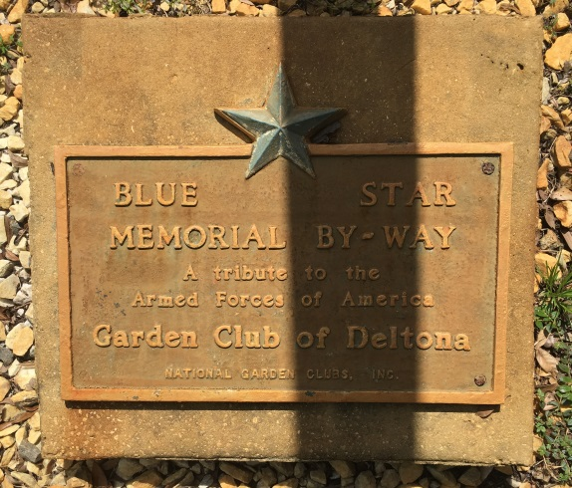
11 | 11/4/2017 | Garden Clubs of Districts VI | Located in Cape Canaveral National Cemetery, 5525 US 1, Mims | Memorial Marker | 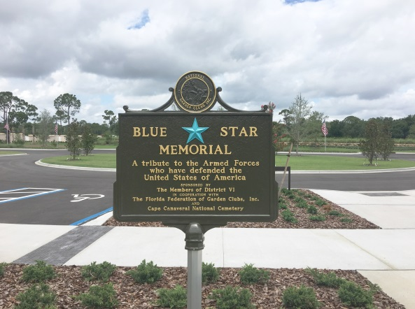
12 | 11/11/21 | Garden Club by the Sea | Located in Lily Park, 8th Avenue & Riverside Drive,  Indialantic | By-Way Marker | 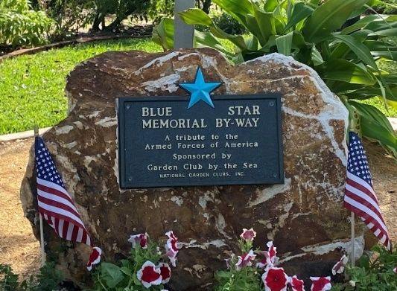

District VII – (Counties: Sumter, Lake, Orange, Osceola and Seminole)

1 | 3/28/1961 | Garden Club of Sanford | Along US 92-17 in island at intersection with Park Drive at south entrance to Sanford | Highway Marker removed by City after auto accident and discarded | 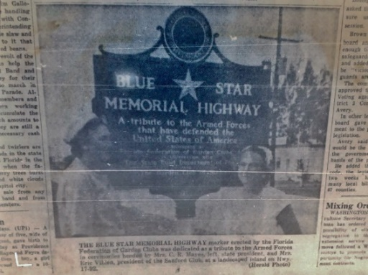
2 | 5/10/1965 | Garden Club  of Orlando | Along US 92-17 on Andrews Causeway (N. Mills Ave.) crossing Lake Estelle, Orlando | Highway Marker missing and presumed lost | 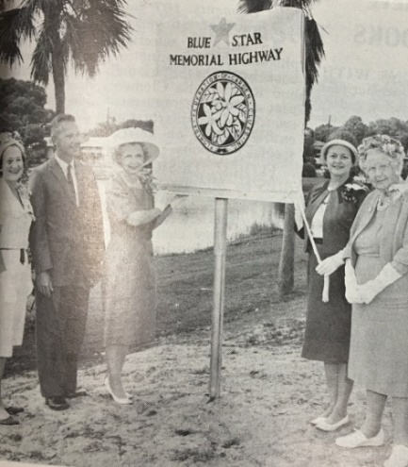
3 | 6/12/1968 | North Orlando Garden Club | Along US 17-92 at intersection with SR 434, (near southern entrance to Longwood) | Highway Marker missing and presumed lost | 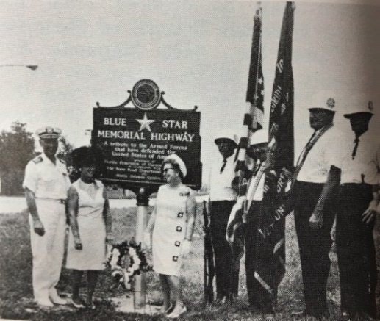
4 | 12/17/1968 | South Seminole Garden Club | Located along US 17 in Fern Park, Longwood | Highway Marker missing and presumed lost | 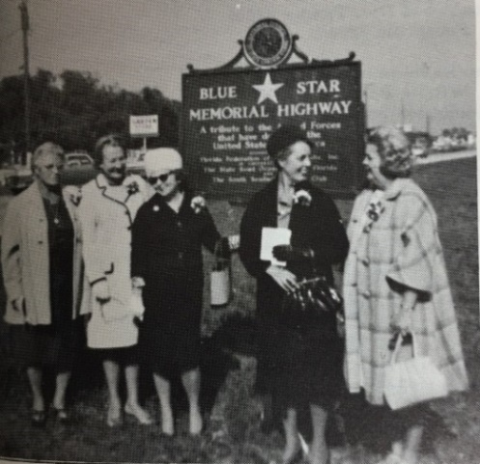
5 | 4/2/1977 | Conway  Garden Club | Located at 3401 Conway Road S. (SR 15) south of Anderson Road in Conway/ Orlando | Highway Marker – orphaned – club no longer in FFGC | 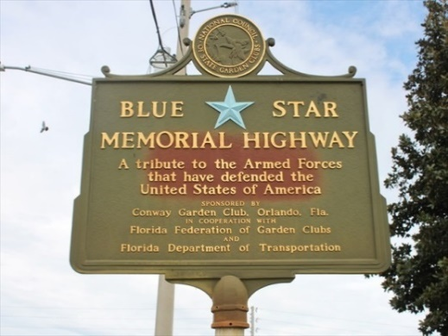
6 | 1/5/2009 | Spring Valley Garden Club | Located on brick wall at entrance to community park across from 802 Spring Valley Road, Altamonte Springs | By-Way Marker | 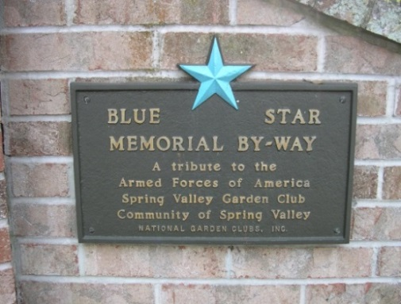
7 | 4/23/2012 | Lady Lake Garden Club | Along US 441 in front of Chamber of Commerce/ Welcome Center, Lady Lake | Highway Marker | 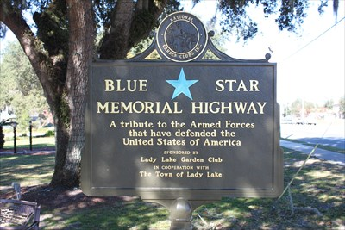
8 | 4/8/2017 | Lakes and Hills Garden Club | Located in Chatauqua Park (1250 Lakeshore Drive), Mt. Dora | By-Way Marker | 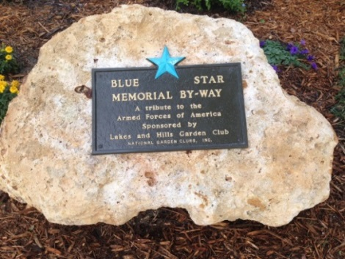
9 | 4/15/2017 | Garden Clubs of Districts V & VII | Located just inside entrance to the Florida National Cemetery, 6502 SW 102nd Ave., Bushnell | Memorial Marker | 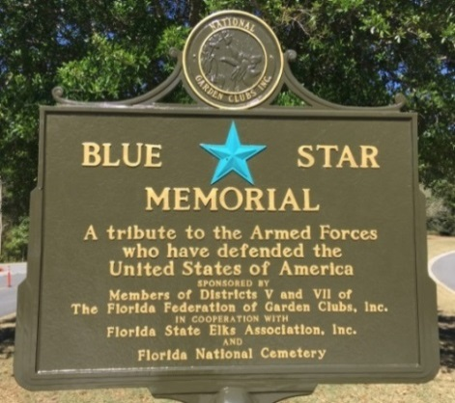
10 | 9/12/2018 | Garden Clubs of the FFGC | Located in front of FFGC Headquarters  1400 S. Denning Drive, Winter Park | Memorial Marker | 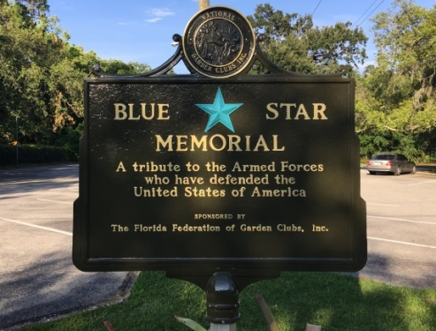
11 | 11/12/2018 | Lakes and Hills Garden Club | Located in Gilbert Park (310 S. Tremain Street) Mt. Dora | Gold Star Families By-Way Marker | 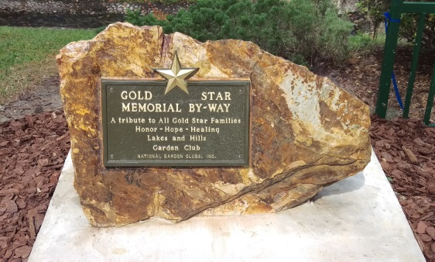
12 | 2/17/23 | Camelia Garden Club | Eustis Public Library, 120 N. Center Street, Eustis | By-Way Marker | Not Yet Available

District VIII – (Counties: Pasco, Hillsborough, Pinellas, Manatee and Sarasota)

1 | 5/21/1958 | St. Petersburg Garden Club | Along US 19 Skyway Blvd. (now I-275) a few yards north of the North Toll Plaza, St. Petersburg | Highway Marker missing and presumed lost | 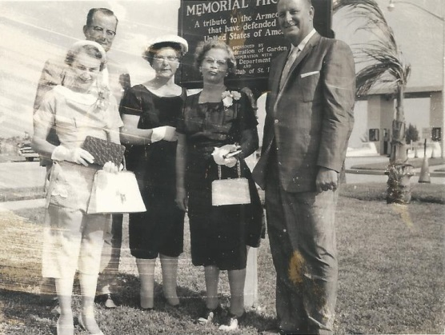
2 | 3/26/1959 | Sarasota Garden Club | Along US 41 East, on the Bayfront opposite Marina Jack just S of Main St., Sarasota | Highway Marker | 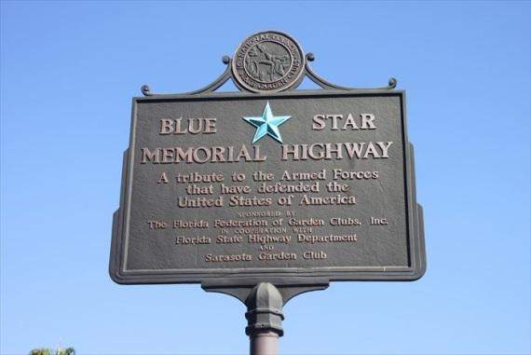
3 | 12/15/1959 | Clearwater Garden Club | Located on State Road 60 on west side of Memorial Causeway Bridge, Clearwater | Highway Marker | 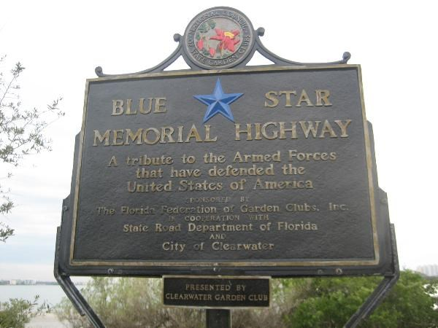
4 | 3/30/1960 | Belleair Garden Club | Located on US 19A, Belleair Blvd & Ft. Harrison Ave., Belleair | Highway Marker – orphaned – club no longer in FFGC; missing & presumed lost | 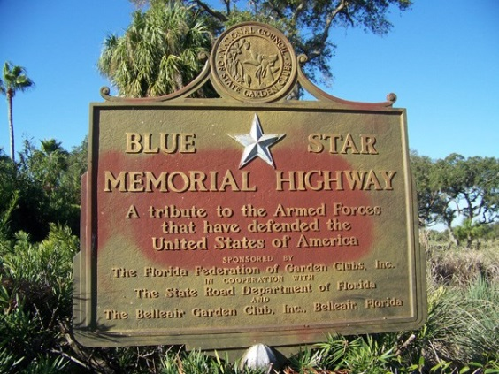
5 | 5/20/1960 | Tampa Federation of Garden Club Circles | Located along US 92 opposite 4600 N. Dale Mabry Hwy. on west side of Al Lopez Park, Tampa | Highway Marker | 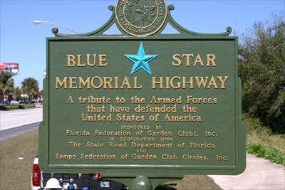
6 | 4/30/1965 | Dunedin Garden Club | Located along US 19 at corner with Pasadena Drive, Dunedin | Highway Marker lost and replaced with a By-Way marker at another location in 2007 | 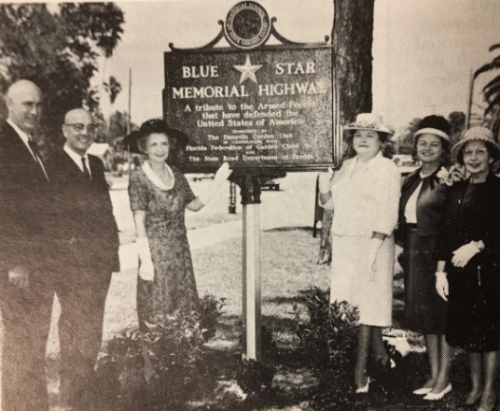
7 | 5/25/1966 | North Tampa Garden Club (adopted & refurbished by Temple Terrace GC) | Located along US 92 or Hillsborough Ave. at N. Florida Ave., North Tampa | Highway Marker – orphaned – club no longer in FFGC | 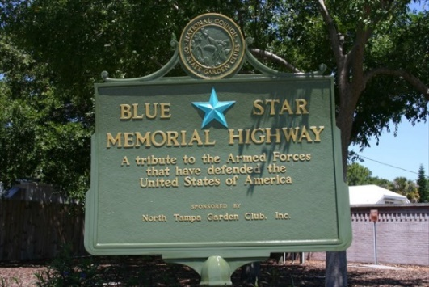
8 | 3/10/1967 | Exotica Garden Club  (adopted by Plant City GC) | Located in Veterans Memorial Park at Courier Field along Wheeler St. (SR 39), Plant City | Highway Marker– orphaned – club no longer in FFGC | 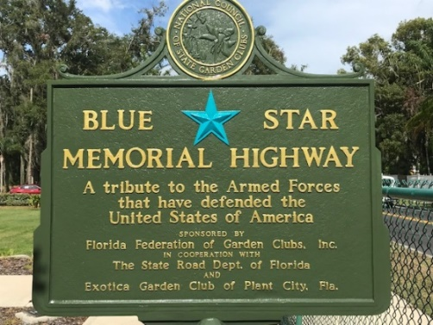
9 | 5/23/1968 | Manatee River Garden Club | Located on American Legion Post 24 grounds at 2000 75th St. West, Bradenton | Highway Marker | 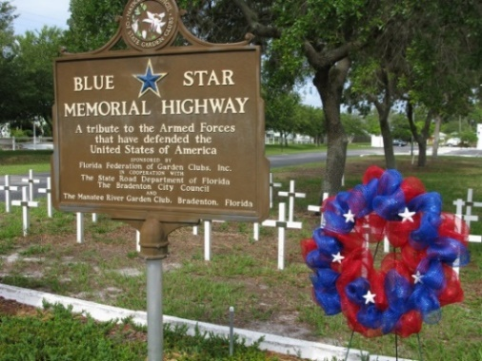
10 | 12/3/1968 | Allamanda  Garden Club | Located along US 41 at corner of Pan Am Blvd. North Port (Charlotte) | Highway Marker –– club no longer in FFGC | 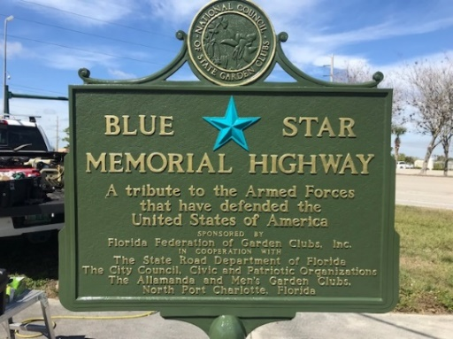
11 | 12/7/1968 | Palmetto Garden Club | Located in median of Business US 41 just north of the intersection with Bayshore Road | Highway Marker – orphaned – club no longer in FFGC | 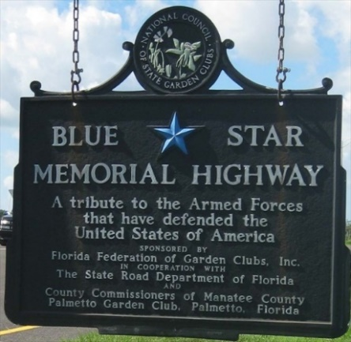
12 | 5/23/1969 | Zephyrhills Garden Club | Located along US 301 at corner of 6th Ave & Gall Blvd., Zephyrhills | Highway Marker (replaced with new marker in 1980) – orphaned – club no longer in FFGC | 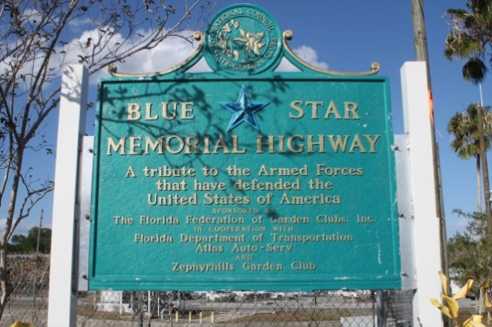
13 | 11/11/1969 | Venice Area Garden Club | located in front of Venice Area Chamber of Commerce, 597 Tamiami Trail S, Venice | Highway Marker | 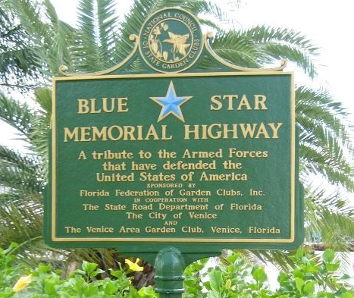
14 | 5/1/1970 | Mango Garden Club (adopted & refurbished by Temple Terrace GC) | Located along C.R. 579 (Mango Road), just south of US 92 Seffner at County Agriculture Extension Office | Highway Marker – orphaned – club no longer in FFGC | 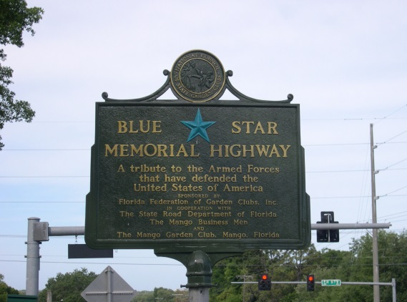
15 | 1975 | North Tampa Garden Club | Located along US 41 at Linebaugh Ave., Tampa | Highway Marker damaged in auto accident and removed | No Photo Available
16 | 2/5/1980 | Top of the Bay Garden Club | Located along US 41 in Canal Park on Tampa Rd & Forest Lake Blvd., Oldsmar | By-Way Marker | 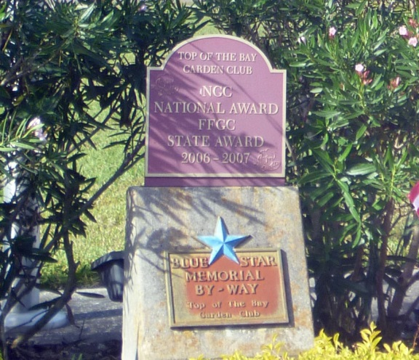
17 | 4/9/1988 | Palm Harbor Garden Club | Located outside the Palm Harbor Library at 2330 Nebraska Ave. (C.R. 776), Palm Harbor | By-Way Marker | 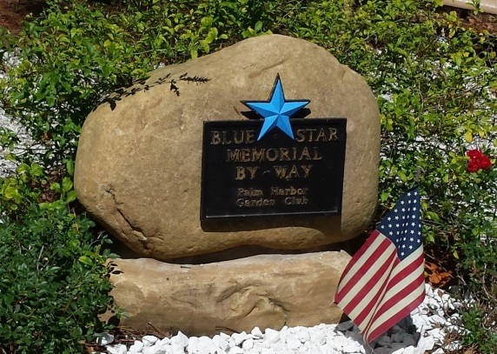
18 | 4/29/2004 | Temple Terrace Garden Club | Located in Woodmont Park, near Golf & Country Club, Temple Terrace | Memorial Marker | 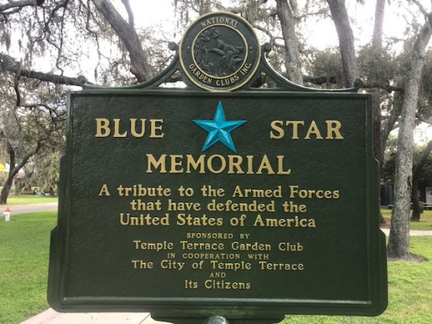
19 | 1/9/2007 | Tarpon Springs Garden Club | Located in Mother Meres Park, Pinellas & Tarpon Aves., Tarpon Springs | By-Way Marker | 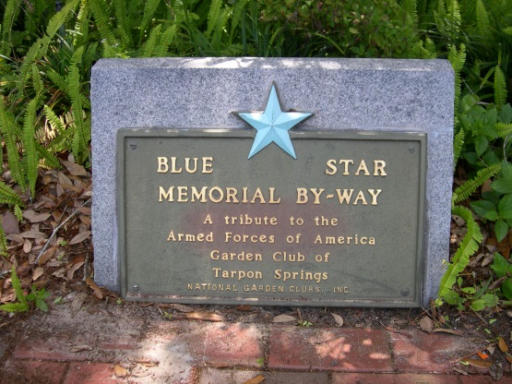
20 | 3/2/2007 | Dade City Garden Club | Located in in Lester Park along US98/301 at south entrance to Dade City | Highway Marker | 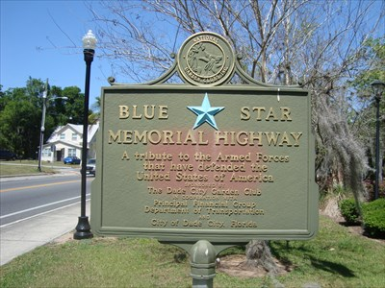
21 | 2007 | Dunedin Garden Club | Located in Armstrong Park at Edgewater Dr. & Main St.,  Dunedin | By-Way Marker | 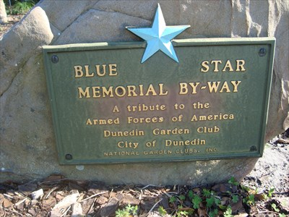
22 | 12/13/2008 | Manatee River Garden Club | Located in in Veterans Memorial Park at 206 2nd St. East, Bradenton | Memorial Marker | 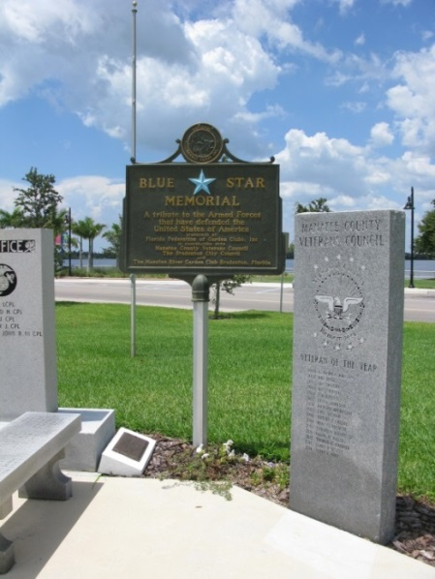
23 | 8/13/2010 | The Elegant Gardeners Club of Sun City Center | Located in median of S.R. 674 at Pebble Beach Blvd., Sun City Center | Highway Marker – orphaned – club no longer in FFGC | 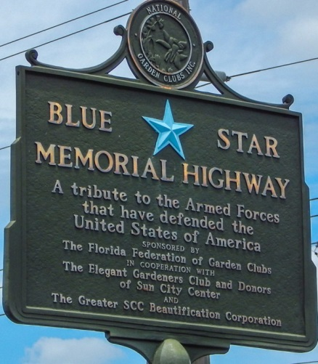
24 | 9/21/2012 | Garden Clubs of District VIII (Timber Pines  Garden Club) | Located in Weeki Wachee State Park, 6131 Commercial Way, Spring Hill | By-Way Marker | 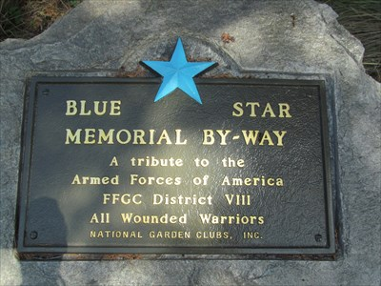
25 | 11/11/2014 | St. Petersburg  Garden Club | Located in Coconut Park, 500 Sunset Dr. South, St. Petersburg | Memorial Marker | 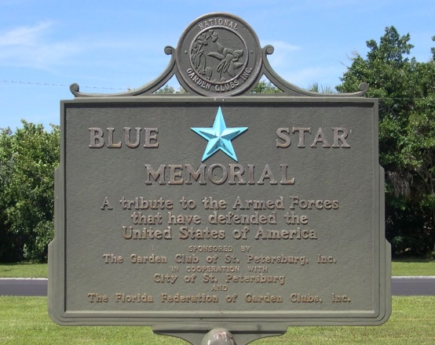
26 | 11/10/2015 | Lemon Bay Garden Club | Located in Englewood Veterans Memorial Park, 10 Harbor Lane, Englewood | Memorial Marker | 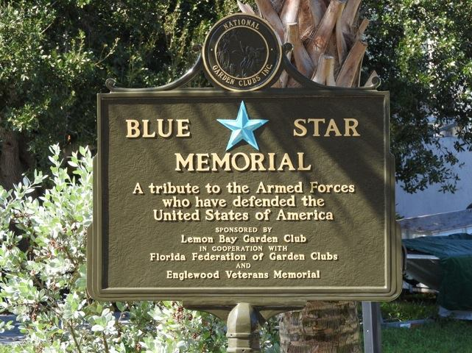
27 | 4/6/2017 | The Garden Clubs of District VIII | Located in Bay Pines National Cemetery, 10000 Bay Pines Blvd. North, St. Petersburg | Memorial Marker | 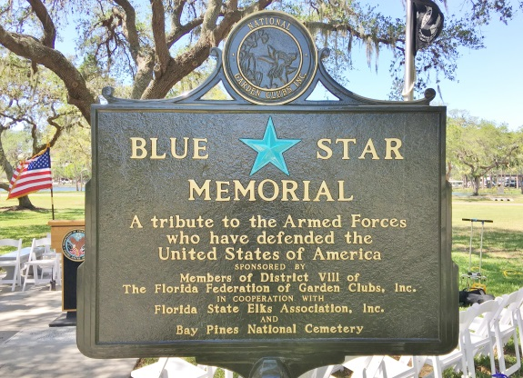
28 | 4/18/2017 | The Garden Clubs of District VIII | Located in Sarasota National Cemetery, 9810 SR 72, Sarasota | Memorial Marker | 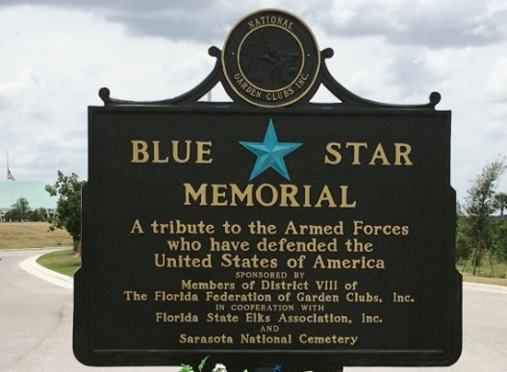
29 | 5/28/2017 | Gardeners Out East Garden Club | Located in front of City Hall, Lakewood Ranch | Memorial Marker | 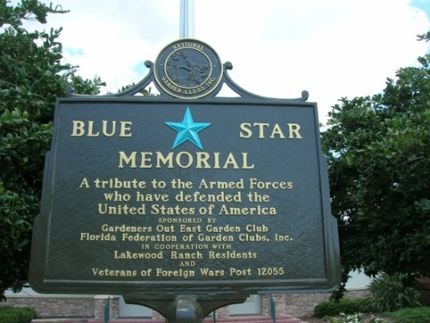
30 | 5/25/2019 | New Port Richey Garden Club | Located at entrance to Country Club at 6300 Timber Greens Blvd.,  New Port Richey | By-Way Marker | 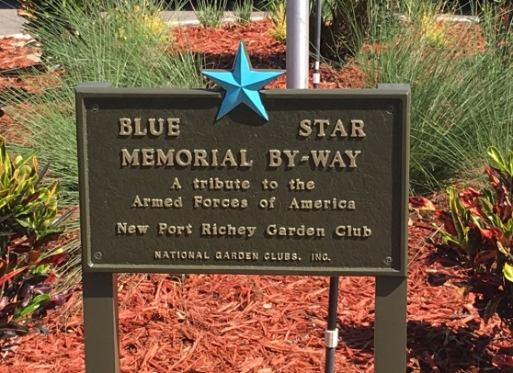
31 | 6/15/2019 | Tampa Federation of Garden Clubs | Located at American Legion Cemetery at 3810 W. Kennedy Blvd., Tampa | Memorial Marker | 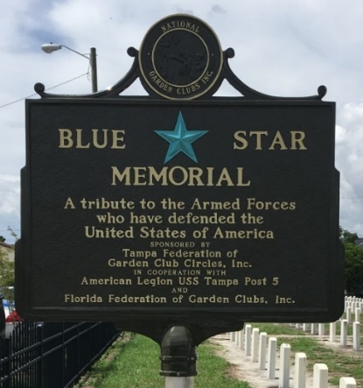
32 | 11/?/2023 | Gardeners Out East Garden Club  (Lakewood Ranch) | Located at Manatee Central  Library 16419 Rangeland  Parkway | Gold Star Families Memorial Marker
District IX – (Counties: Polk, Hardee, DeSoto, Highlands, Charlotte, Lee and Collier)

1 | 5/18/1964 | Winter Haven Council of Garden Clubs | Along US 17 North - just south of Haverdale Blvd. (Inman Park), Winter Haven | Highway Marker | 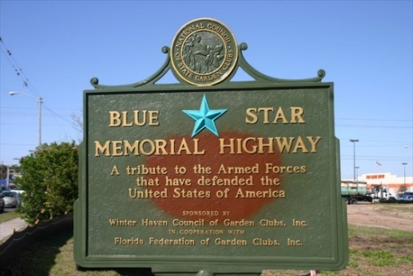
2 | 6/10/1964 | Garden Club of Lakeland | Along on the south side of US 92 at intersection with Gary Road, Lakeland | Highway Marker – replaced with a new marker in 2002 across the street in Sertoma Park, Lakeland | 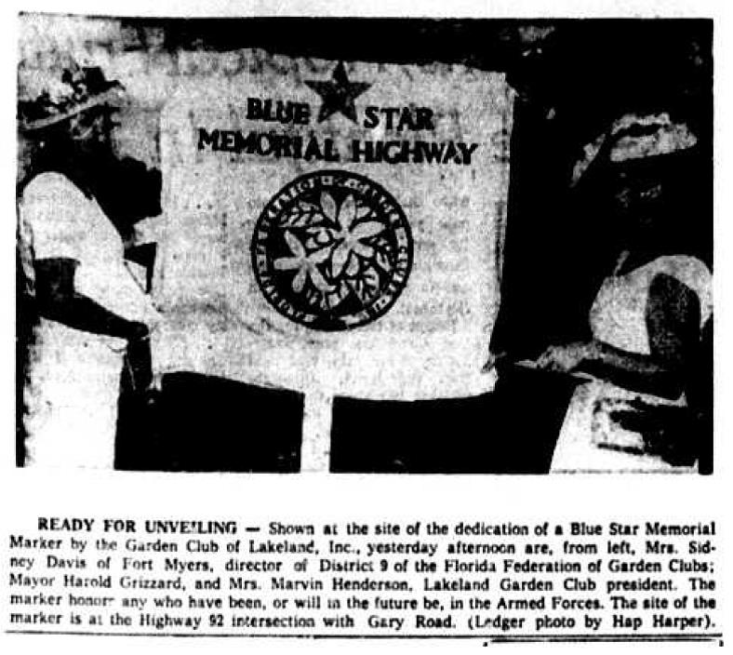
3 | 10/16/1964 | Periwinkle Garden Club | In median of US 41 S, just south of Winklar Ave. in front of Sears bldg. at Edison Mall, Fort Myers | Highway Marker – missing and presumed lost | 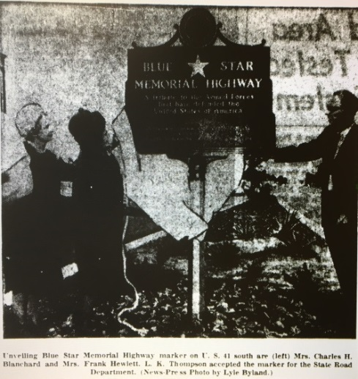
4 | 3/23/1965 | Founders Garden Club of Avon Park | Located on northeast side of the intersection of US 27 & CR 64 (Main Street), Avon Park | Highway Marker | 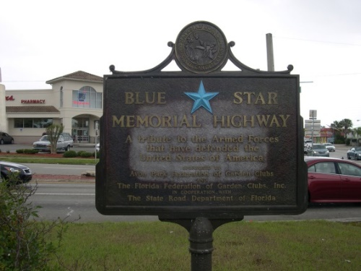
5 | Dedication date not known (1965-1968?) | Garden Club of Lake Wales | Located along US 98 (US27A) near historic rail depot at 325 South Scenic Highway, Lake Wales | Highway Marker – original marker replaced in 2007 | 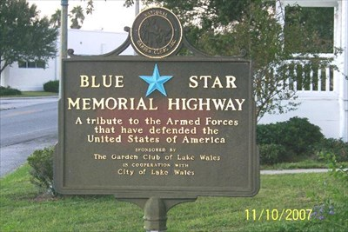
6 | 5/5/1968 | Davenport Garden Club (no longer in FFGC) | Located at NE corner of W. Williams Street and US17, Davenport | Highway Marker – replaced by Davenport Historical Society after being removed and lost by FDOT | 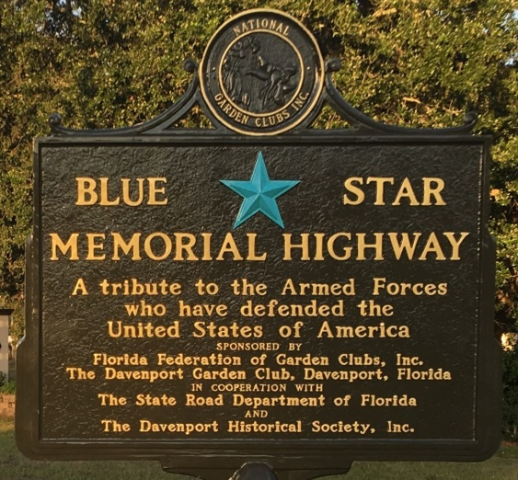
7 | 5/10/1968 | Highlands Garden Club | Located along US 98 & 27 at intersection with SE Lakeview Drive, Sebring | Highway Marker – orphaned – club no longer in FFGC;  Adopted by Sebring GC | 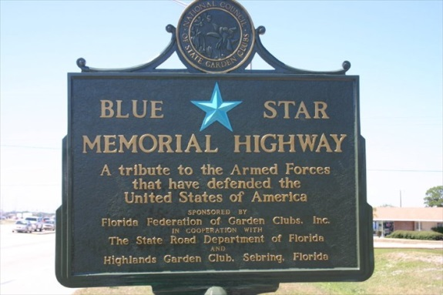
8 | 5/13/1968 | Punta Gorda Garden Club | Located along median of US 41 & Carmelita St. in center of town, Punta Gorda | Highway Marker | 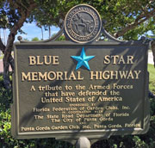
9 | 11/11/1968 | Naples Garden Club | Located in the median of US 41 at 7th Avenue, Naples | Highway Marker | 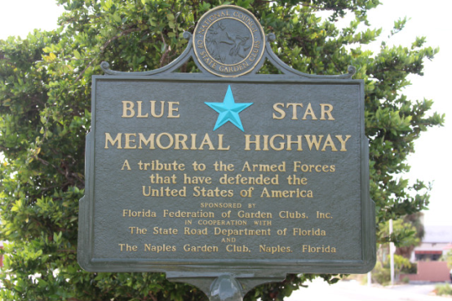
10 | 11/12/1968 | Edison Garden Club | Located in the median of US 41, Fort Myers | Highway Marker – missing and presumed lost | 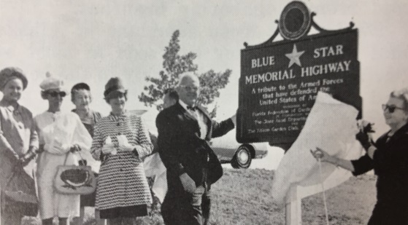
11 | 6/1/1971 | Garden Gate Circle of the Bartow  Garden Club | Located along US 98, at corner of Lyle Pkwy on northeast side at Fort Frasier trailhead, Bartow | Highway Marker – restored by the Polk County Historical Society in 2015 | 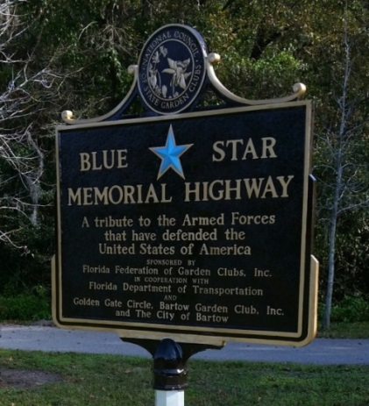
12 | 4/22/1977 | Arcadia Garden Club | Located off US 17 North, near Police Department across from Ace Hardware, Arcadia | Highway Marker | 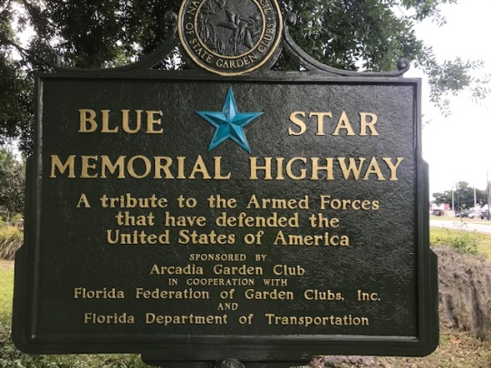
13 | 4/28/1977 | Bartow Garden Club | Located along US 98 South in median opposite Walmart’s old location, Bartow | Highway Marker – removed by FDOT during road work and now lost | No Photo Available
14 | 11/11/1983 | Driftwood Circle of Bartow Garden Club | Located along US 17, Bartow | Highway Marker – missing and presumed lost | 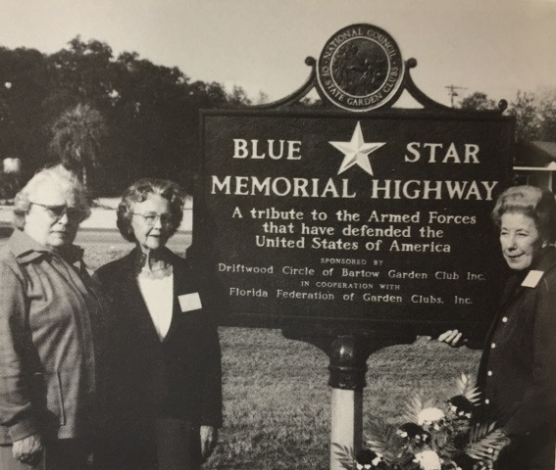
15 | 5/6/1992 | Lake Placid Garden Club | Located off US 27 North – in front of American Legion Post 25; just north of Lake Placid at Luke Henry Drive | Highway Marker | 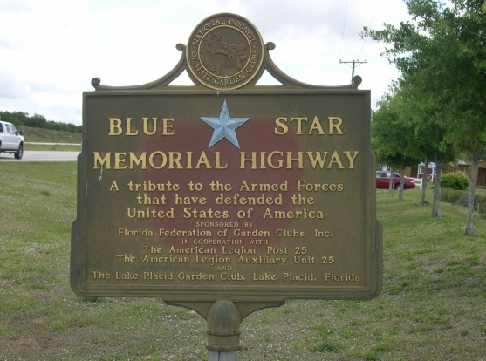
16 | 5/31/2002 | Garden Club of Lakeland | Located along US 92, near corner of Memorial Blvd. and N. Wabash Ave., Lakeland | Highway Marker;  destroyed by rioters in 2020 | 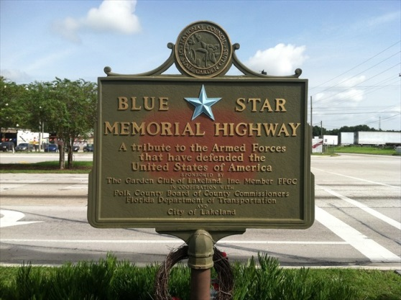
17 | 5/31/2002 | Garden Club of Lakeland | Located along US 92 at Sertoma Park (near entrance) at south end of Lake Parker, Lakeland | Highway Marker – replaced the 1964 marker across the street | 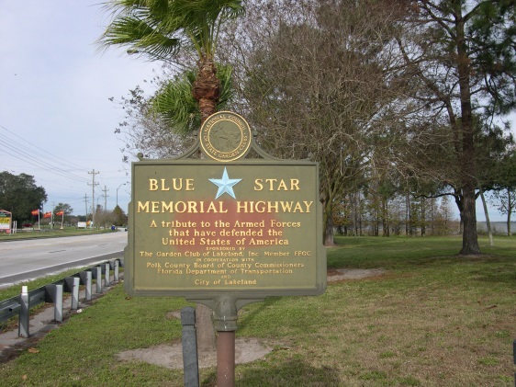
18 | 11/12/2013 | Calusa Garden Club of Marco Island | Located in Veterans Community Park, at 901 Park Ave., City of Marco Island | Memorial Marker | 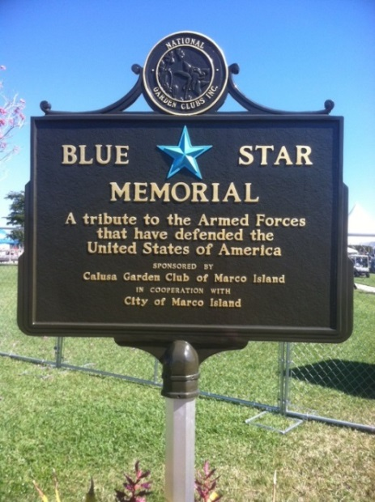
19 | 5/17/2014 | Port Charlotte Garden Club | Located at Douglas T. Jacobson State Veterans Home, 21281 Grayton Terrace, Port Charlotte | Memorial Marker | 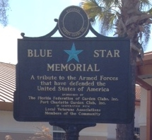
20 | 10/10/2014 | Ft. Myers-Lee County Garden Council | Located in front of Base Ops. Terminal Bldg., 5200 Captain Channing Dr., Page Field, Ft. Myers | Memorial Marker | 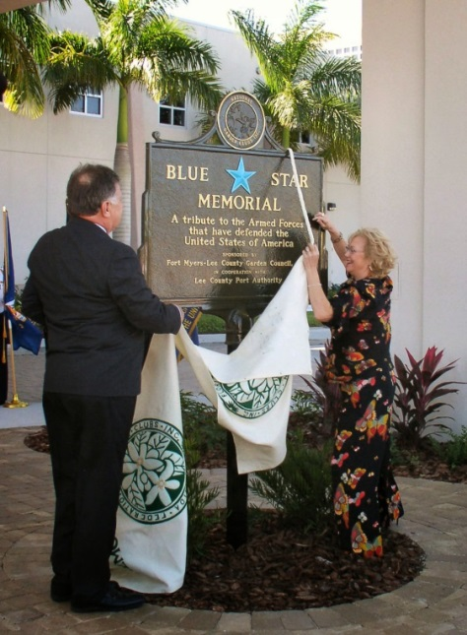
21 | 1/11/2019 | Ft. Myers-Lee County Garden Council | At the NW corner of the Collaboratory  property 2031 Jackson Street,  Ft. Myers | Memorial Marker | 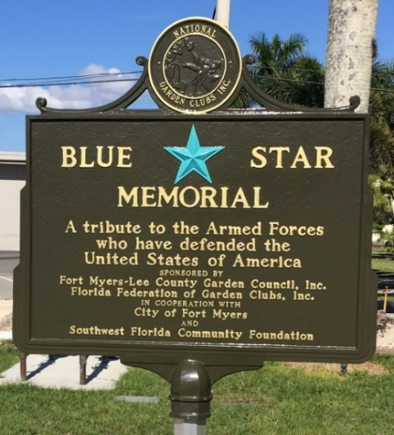
22 | 11/11/2019 | Wauchula Garden Club | At the SE corner of  VFW Post 2  Property on Palmetto St. facing US17,  Wauchula | Highway Marker | 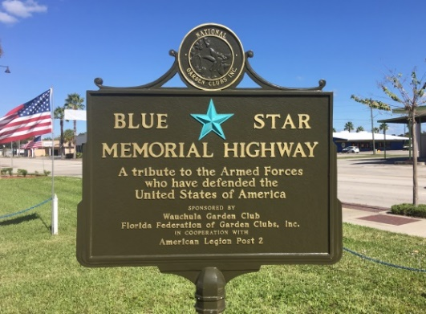
23 | 11/30/2020 | Garden Club of Cape Coral | In Eco Park at 2500 SE 24th Street, Cape Coral | Memorial Marker | 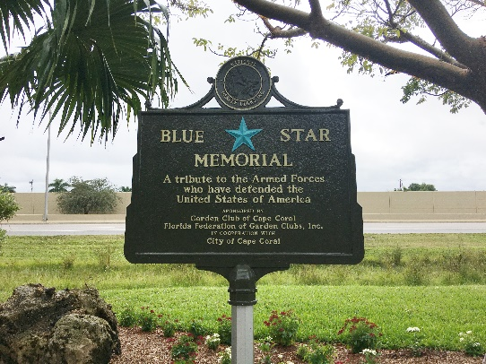

24 | 3/29/2021 | Gulf Coast Garden Club | Across from Riverside Park along Old US 41 near Reynolds St., Bonita Springs | Memorial Marker | 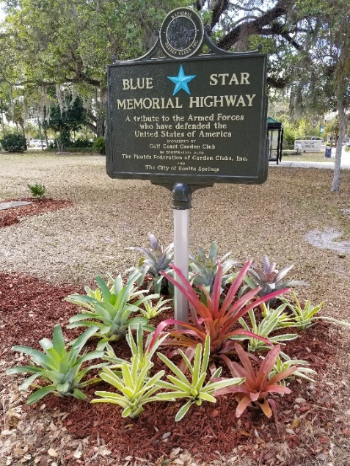
25 | 4/20/2021 | Punta Gorda Garden Club | In Laishley Park near Veterans Plaza, Punta Gorda | Memorial Marker | 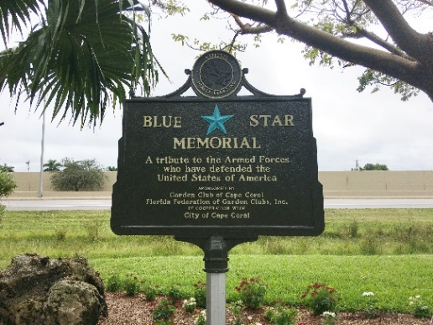
26 | 5/22/2021 | Estero Island Garden Club | Ft. Myers Beach Library, 2755 Estero Blvd, FMB | Memorial Marker; marker apparently destroyed by Hurricane Ian in 2022 | 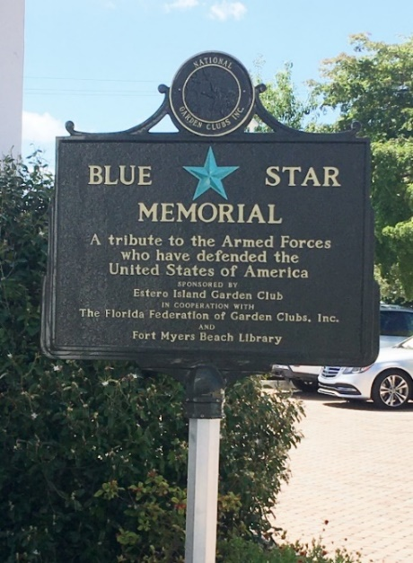
27 | 11/15/22 | Garden Club of Lakeland | Located in Veterans Park, 12 Lake Beulah Drive, Lakeland | Memorial Marker | 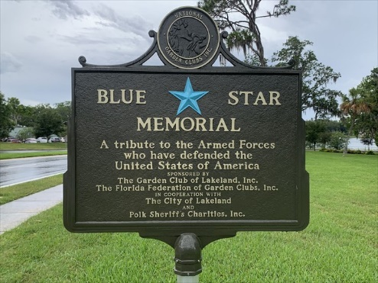
28 | 11/5/22 | Port Charlotte Garden Club | William R. Gaines Jr. Veterans Memorial Park, 20499 Edgewater Drive, Port Charlotte | Gold Star Families Memorial Marker | 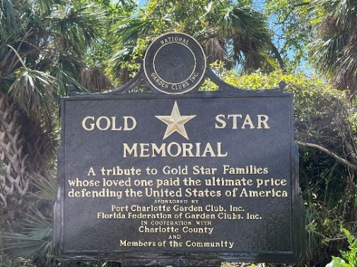
District X – (Counties: Okeechobee, Indian River, St. Lucie, Glades, Martin, Hendry and Palm Beach)

1 | 6/4/1958 | Boca Raton Garden Club | Located along US 1 at the south end of Boca Raton in the median opposite 23rd St. | Highway Marker moved to Sanborn Park and later replaced with new marker in 1977 | 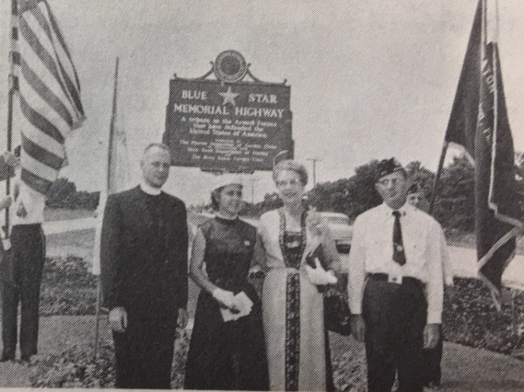
2 | 5/3/1961 | Orchid Garden Club of the Delray Beach Foundation | Located in the grassy median triangle on US 1 north of NE 8th Street, Delray Beach | Highway Marker missing (stolen) and presumed lost | 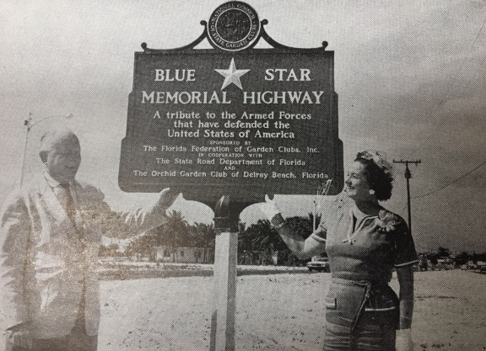
3 | 10/17/1962 | Riviera Beach Garden Club | Located on the east side of US 1 on Port of Palm Beach property in Riviera Beach | Highway Marker missing and presumed lost | 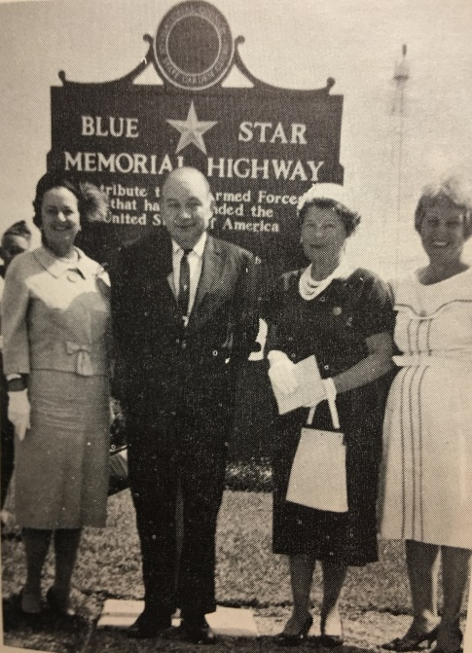
4 | 11/11/1964 | Town & Country Garden Club | Located in Constitution Walk Park at Federal Highway & 19th St. N in, Lake Worth | Highway Marker - restored Sept., 2012 – orphaned – club no longer in FFGC | 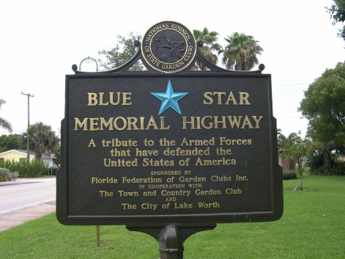
5 | 12/31/1964 | Okeechobee Garden Club  (club no longer in FFGC) | Located along east side of Veterans Park near intersection of US 98, 441 & SR 710 (US 70), Okeechobee | Highway Marker - replaced August, 2008 – installed by city in November, 2015 – orphaned;  Destroyed by auto 2022 | 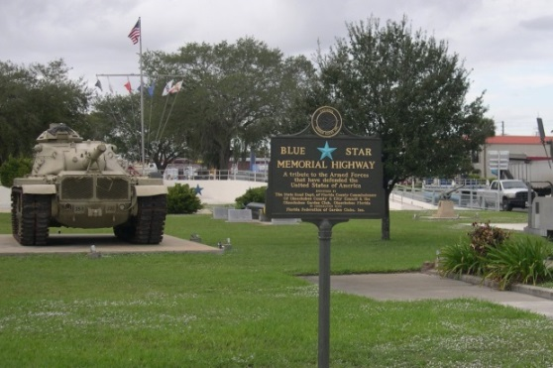
6 | 10/31/1966 | West Palm Beach Garden Club | located at north end of Prospect Park at Olive Ave. (Federal Highway) and Buckingham, West Palm Beach | Highway Marker - restored early 2016 | 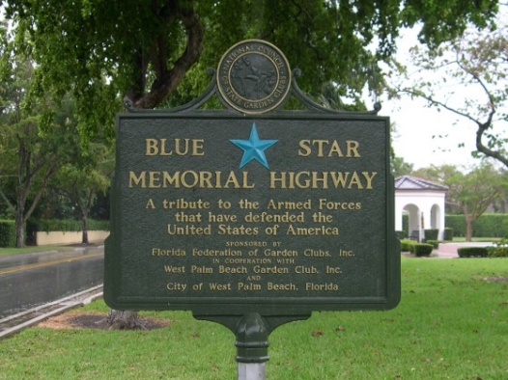
7 | 4/25/1968 | Boynton Beach Garden Club | Located along US 1 at north entrance to Boynton Beach (across from Yachtsman Plaza) | Highway Marker -restored March, 2010 | 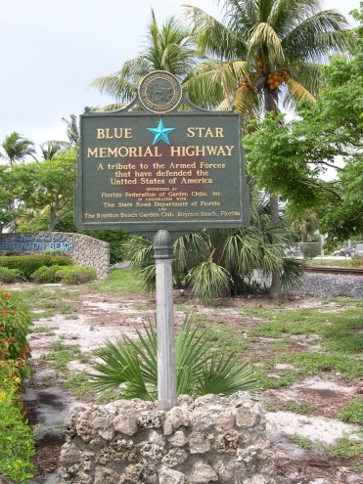
8 | 3/5/1969 | Canal Point Garden Club | Located along US 98 & 441, across from Canal Point Community Center at 12860 US 441, Canal Point | Highway Marker – orphaned – club no longer in FFGC | 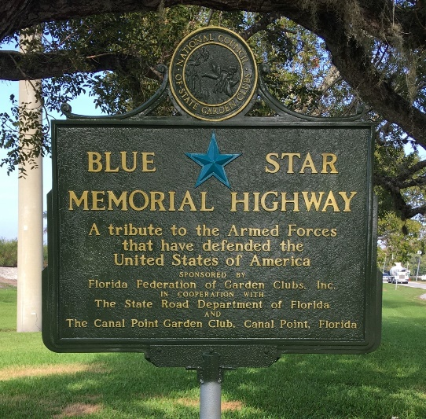
8 | 5/141971 | North Palm Beach Garden Club | located in median of US 1 across from 910 Federal Hwy., North Palm Beach | Highway Marker -restored August, 2013 – orphaned – club no longer in FFGC | 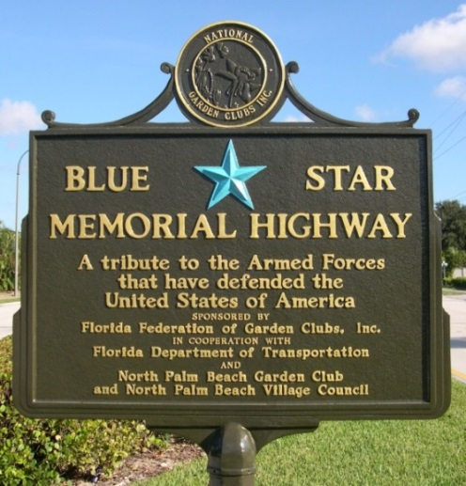
9 | 4/14/1973 | Lake Park Garden Club | Located along US 1 at southern end of Kelsey Park, Lake Park | Highway Marker missing (stolen) and presumed lost | No Photo Available
10 | 11/3/1977 | West Palm Beach Garden Club | Located at the SE corner of Parker Ave. and Okeechobee Blvd. in Howard Park, West Palm Beach | Highway Marker removed and scrapped due to extensive surface damage | 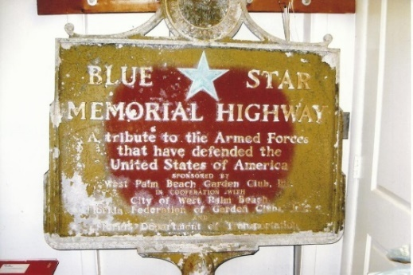
11 | 4/2819/77 | Boca Raton Garden Club | Located along US 1 in Sanborn Square Park, 72 N. Federal Highway, Boca Raton | Highway marker -restored February, 2015 | 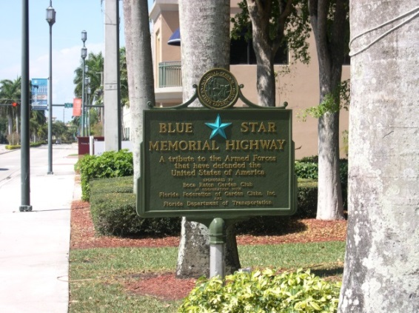
12 | 1/14/2006 | Boca Raton Garden Club | Located in front of Boca Raton G.C. Clubhouse at 4281 NW 3rd Avenue, Boca Raton | By-Way Marker | 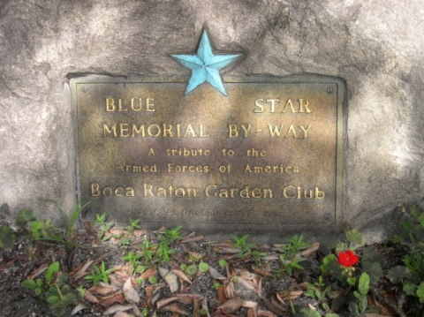
13 | 11/11/2007 | Garden Clubs of District X | Located at SE corner of Wabasso Drive & Saranac Ave., Westgate Village, West Palm Beach | By-Way Marker -  moved to and replaced in Veterans Park in Royal Palm Beach | 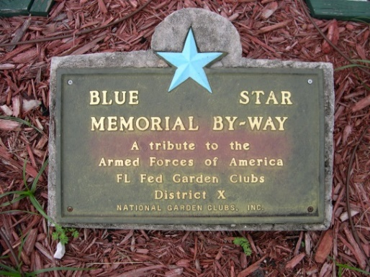
14 | 1/18/2012 | Garden Club of Stuart | Located on south side of Veteran’s Memorial Park at 300 SE Ocean Blvd., Stuart | By-Way Marker | 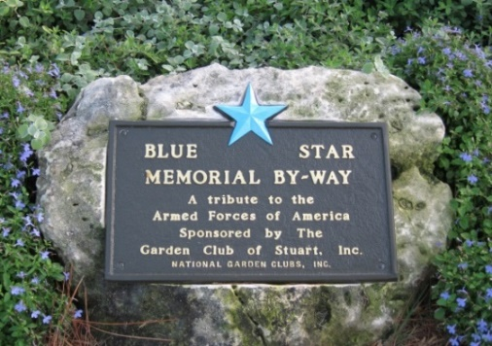
15 | 11/11/2014 | District X | Located in Royal Palm Beach Veteran’s Park at 1036 Royal Palm Beach Blvd., Royal Palm Beach | By-Way Marker | 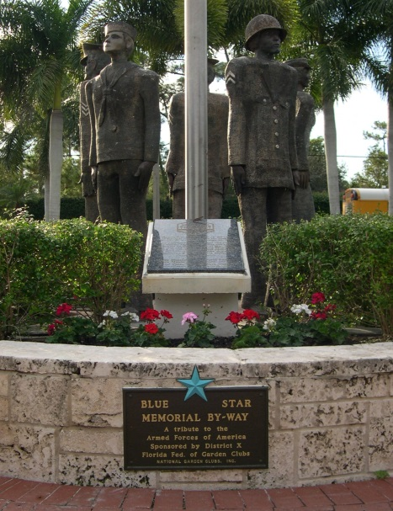
16 | 11/11/2016 | Jensen Beach Garden Club | Attached to southeast side of Stuart Welcome Arch  CR 707, Jensen Beach | By-Way Marker | 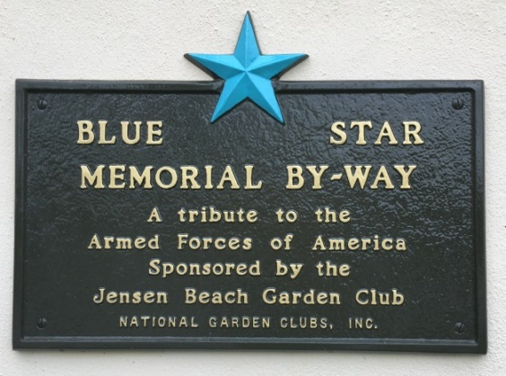
17 | 11/18/2016 | Garden Clubs of Districts X, XI & XII | Located in front of Admin. Bldg. at South Florida National Cemetery  6501 S. SR 7,  Lake Worth | Memorial Marker | 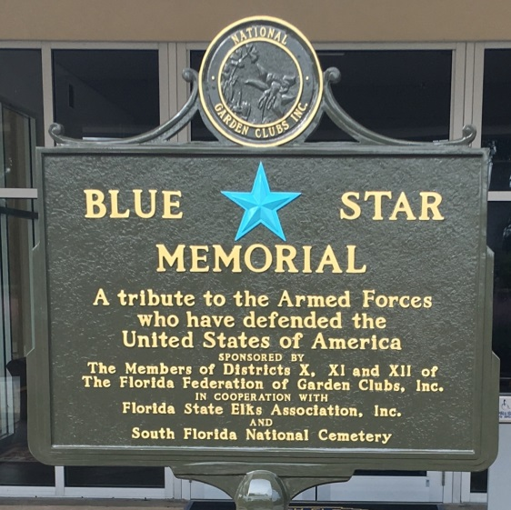
18 | 3/19/2017 | Oleander Garden Club of the Palm Beaches | Located in front of WPB Elks Lodge at 1352  6188 Belvedere Rd., West Palm Beach | By-Way Marker | 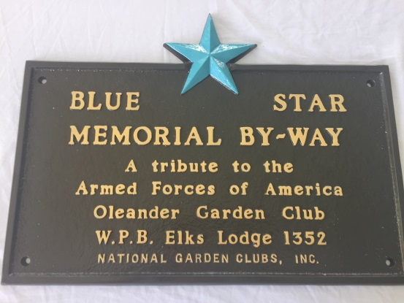
19 | 3/1920/17 | Oleander Garden Club of the Palm Beaches | Located in front of WPB Elks Lodge at 1352  6188 Belvedere Rd., West Palm Beach | Gold Star Families By-Way Marker | 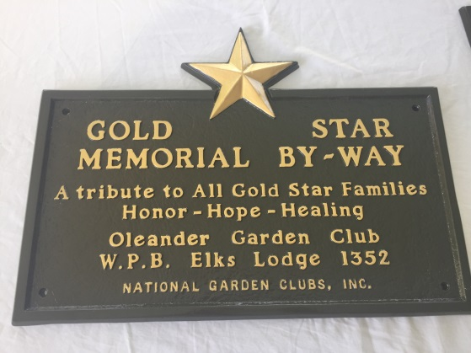
20 | 4/2/2017 | Rio Lindo Garden Club of Port St. Lucie | Located in median of 2100 SE Veterans Memorial Blvd.,  Port St. Lucie | Memorial Marker | 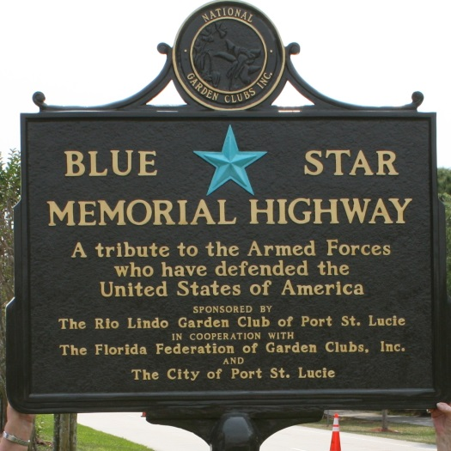
21 | 02/22/2019 | Garden Club of Indian River County | Located at City Hall, 1053 20th Place, Vero Beach | Memorial Marker | 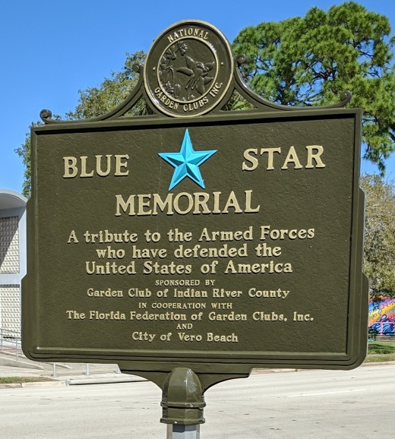
22 | 03/16/2019 | Fort Pierce Garden Club | Located in Veterans Park at 600 N. Indian River Drive, Fort Pierce | By-Way Marker | 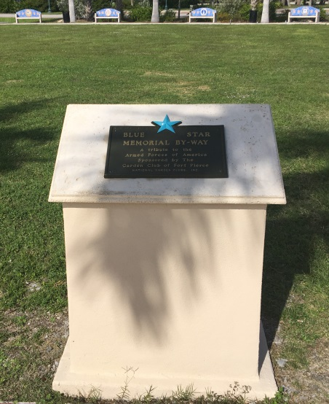
23 | 05/27/2019 | Palm Beach Gardens Garden Club | Located at south end of Kelsey Park adjacent to US1 (601 US Hwy 1), Lake Park | Gold Star Families Memorial Marker | 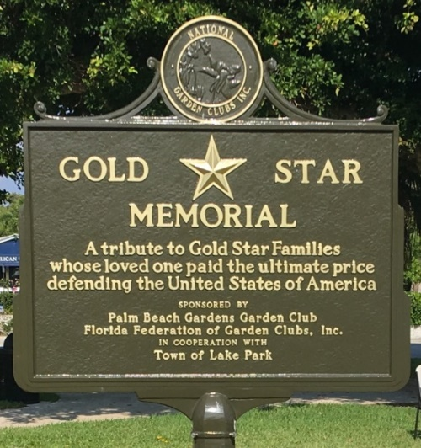
24 | 05/27/2019 | Ocean Ridge Garden Club | Located at Ocean Ridge Town Hall at 6450 N. Ocean Blvd., Ocean Ridge | Memorial Marker | 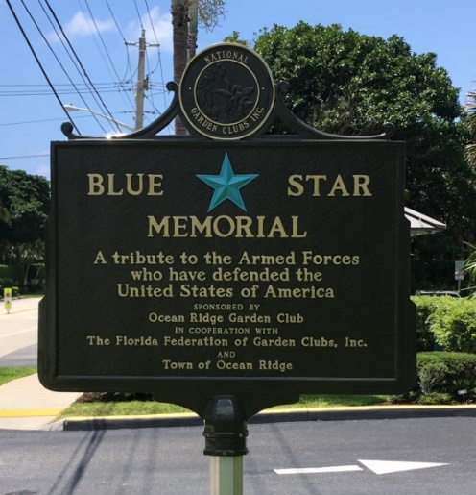
25 | 11/11/2019 | Wellington Garden Club | Located in Wellington Veterans Memorial Park at corner of South Shore Blvd. and Forest Hill Blvd., Wellington | Memorial Marker | 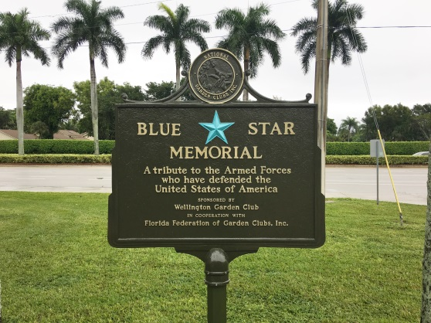
26 | 11/11/2020 | St. Lucie West Garden Club | Located in median of Crosstown Parkway near Floresta Dr.,  Port St. Lucie | Memorial Marker | 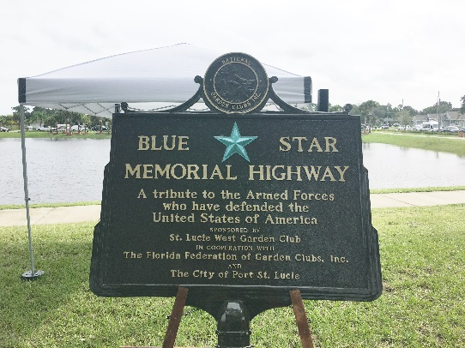
26 | TBA | Hamlet Garden Club  (disbanded, 2020) | east side of intersection of A1A & Atlantic Ave., Delray Beach | By-Way Marker | Not Yet Available
27 | 5/31/2021 | Wellington Garden Club | Located in Veterans Park, 14001 Pierson Road, Wellington | Gold Star Families Memorial Marker | 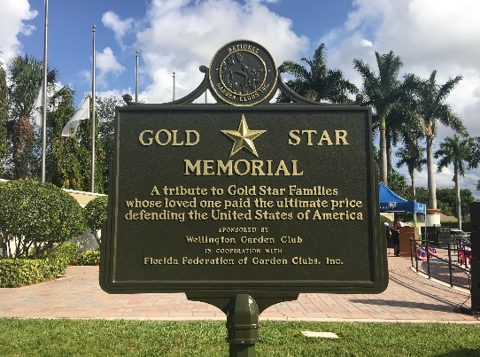

District XI – (Counties: Broward)

1 | 5/3/1954 | Pompano Beach Garden Club | Along US 1 in median of Federal Highway near SE 5th Street, Pompano Beach | Highway Marker | 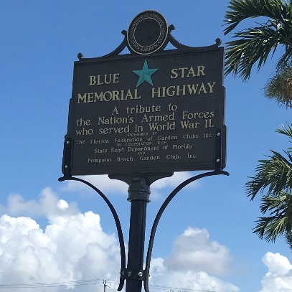
2 | 2/23/1963 | Deerfield Beach Garden Club | Along US 1 in median across from Duffy's Restaurant at NE 4th Street, Deerfield Beach | Highway marker missing and presumed lost | 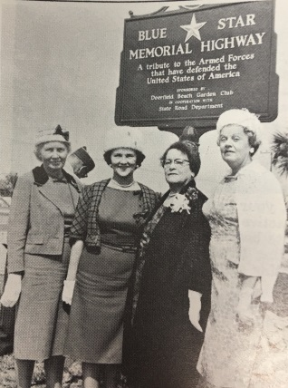
3 | 5/6/1964 | Federated Garden Circles of Ft. Lauderdale | Along US 1 at South 32nd street, Fort Lauderdale | Highway Marker (original marker lost and then replaced in 2009) | 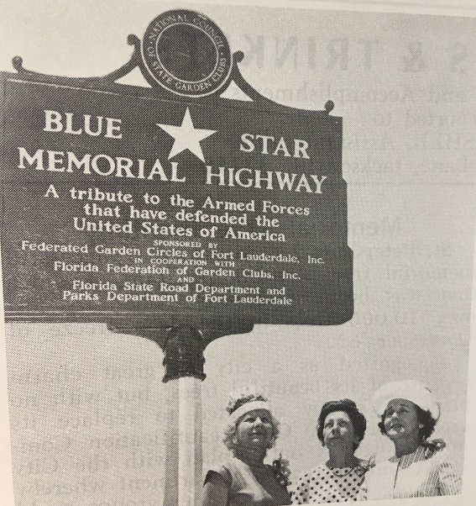
4 | 11/11/1966 | Dania Beach Garden Club | Located along North Federal Highway (US 1) at wayside park in Dania Beach | Highway Marker missing and presumed lost | 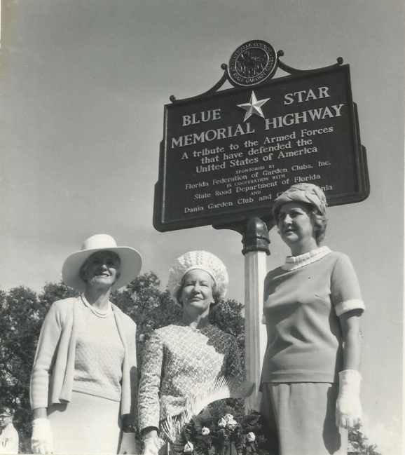
5 | 12/7/2009 | Ft. Lauderdale  Garden Club | Located on US1 near CR 84 at SE 26th Street, Fort Lauderdale | Highway Marker (replaced 1964 marker)  Now currently missing and presumed lost | 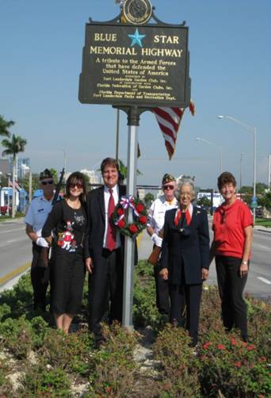
6 | 11/18/2016 | Garden Clubs of District X, XI and XII | Located in South Florida National Cemetery  6501 S. SR 7  Lake Worth | Memorial Marker | 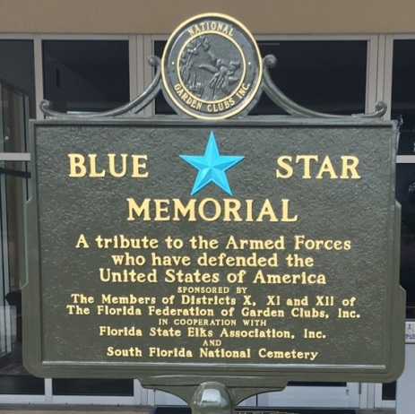
7 | 11/11/2020 | Garden Club of Coral Springs | Located in Veterans Park, 8601 Royal Palm Blvd., Coral Springs | By-Way Marker | 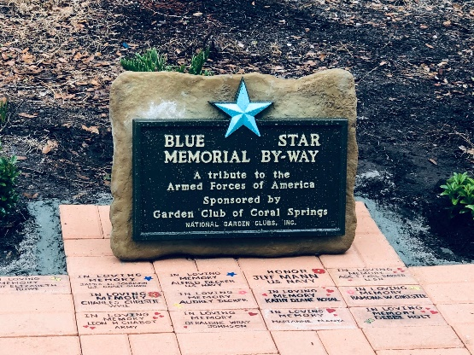

District XII – (Counties: Dade and Monroe)

1 | 5/30/1949 | Key West Garden Club  (club no longer in FFGC) | At southern terminus of US 1 in the Veterans Memorial Garden at Bayview Park in Key West | Highway Marker (replaced several times – most recently in 2015) | 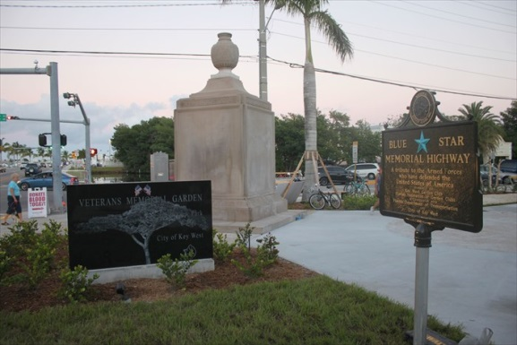
2 | 9/25/1954 | Tropical Garden Club | In median of US 1 at 48th St.; in front of Bay Point Medical Center at 4770 Biscayne Blvd., Miami | Highway Marker –– club no longer in FFGC.  Marker adopted by Miami Beach GC | 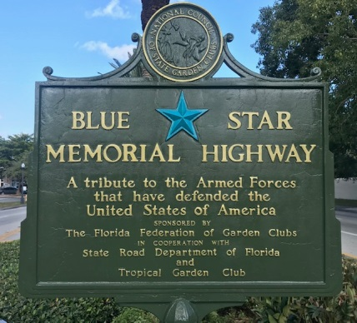
3 | 4/26/1963 | Miami Garden Club | Located on west side of U.S. 1 (Dixie Hwy.) just south of the east entrance to Greynolds Park, North Miami Beach | Highway Marker missing and presumed lost | No Photo Available

4 | 3/12/1967 | Dig and Dream Garden Club  (in cooperation with Tao Ti High School Gardeners) | Located in median of US 1, at Suniland Shopping Center near SW 112th Street in Pinecrest section of Miami | Highway Marker missing and presumed lost | No Photo Available
5 | 5/29/1968 | Marathon  Garden Club | Located near US 1 intersection with 122 Street Ocean, Marathon | Highway Marker | 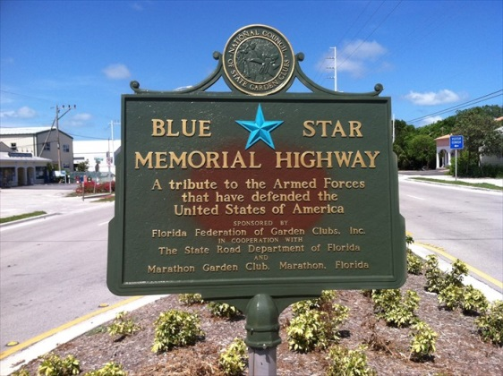
6 | 5/8/1970 | Key Largo Garden Club  (club no longer in FFGC) | Located on US 1 near Atlantic Blvd., Key Largo | Highway Marker | 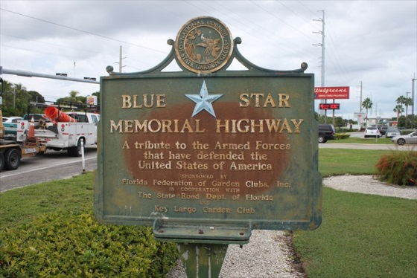
7 | 10/6/1974 | ??? Garden Club | Along US 41, Miami | Highway Marker  Missing and presumed lost | No Photo Available
8 | 11/13/1976 | Ives Estates Garden Club | Along Ives Dairy Road (SR 854) at NE 14th Ave., North Miami Beach | Highway Marker missing and presumed lost | 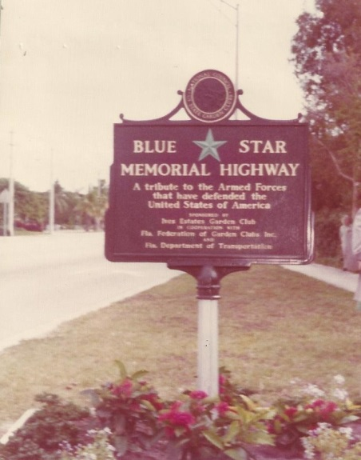
9 | 2/1/1980 | Miami Beach Garden Club | Located off Julia Tuttle Causeway west of Alton Road, Miami Beach | Highway Marker (obtained from Key West GC and re-furbished) | 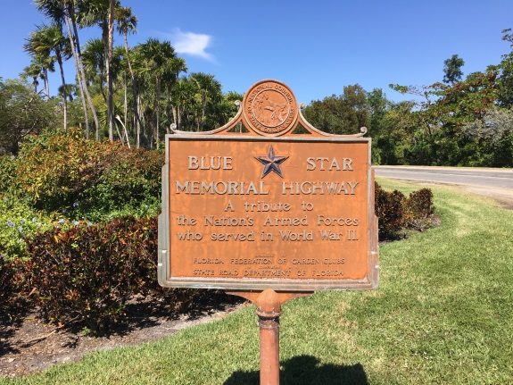
10 | 12/3/1981 | Biltmore Heights Garden Club (club no longer in FFGC) | Formerly located at entrance of City of South Miami at SW 80th St and US 1, South Miami | Highway Marker lost and replaced by South Miami GC (See #14) | 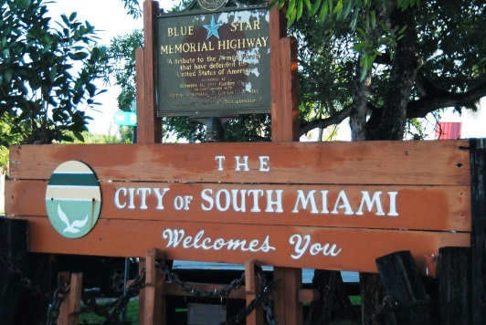
11 | 5/11/1982 | South Dade Garden Club | Located along US 1 in Homestead | Highway Marker missing and presumed lost | No Photo Available  No Photo Av  ailable
12 | 1/10/2009 | Green Thumb Garden Club | Located in Griffing Park (12220 Griffing Blvd.), North Miami | By-Way Marker – orphaned – club no longer in FFGC | 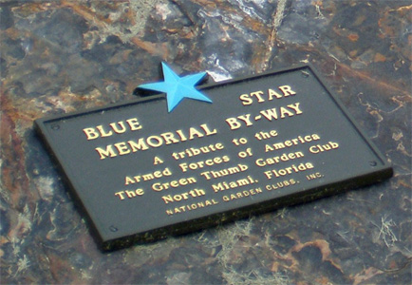
13 | 12/3/1981 | Garden Clubs of Districts X, XI and XII | Located just inside South Florida National Cemetery at 6501 SR 7, Lake Worth | Memorial Marker | 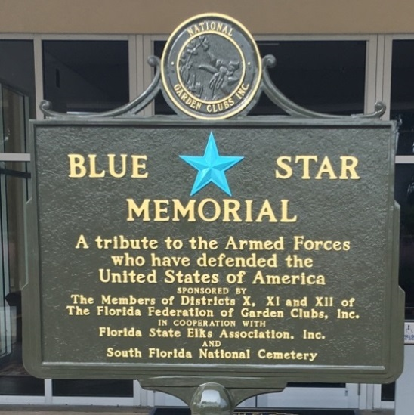
14 | 11/4/2017 | South Miami Garden Club | Located in City of South Miami's Fuchs Park at SE 80th St and US 1, South Miami | Highway Marker – (replace-ment of Biltmore Heights GC marker) | 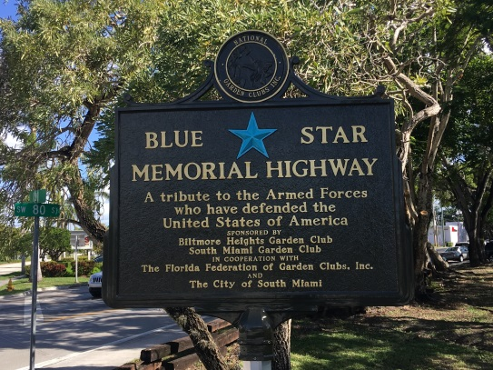
15 | 11/9/2018 | Coral Gables Garden Club | Located in front of Coral Gables War Memorial Youth Center at 405 University Drive, Coral Gables | Memorial Marker | 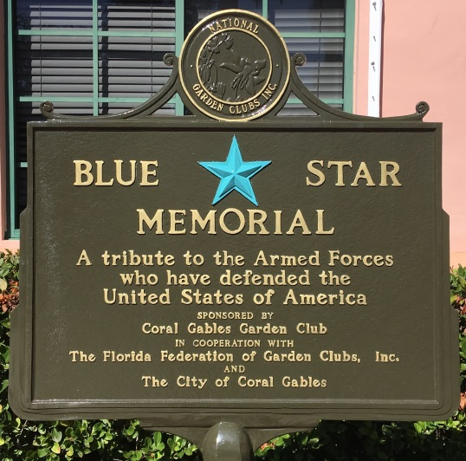
16 | 11/9/2019 | Miami Beach Garden Club | Located along west side of Alton Road just off eastern terminus of Julia Tuttle Causeway | Highway Marker | 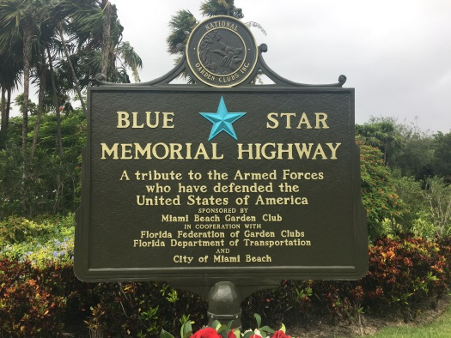
17 | 2/18/2020 | Pinecrest Garden Club | Located in Veterans Wayside Park, 11111 Pinecrest Parkway  (US 1) | Highway Marker | 