FFGC Centennial Quilt Directions
For a $1 reservation fee, you will receive a packet that contains the simple directions for this 2-seams quilt square and the white muslin strip to use as the center. Please read through the directions before you begin!
- Cut paper 8” x 8”. Fold to make a triangle. Crease. Fold again to make a smaller triangle. Crease. Open flat.
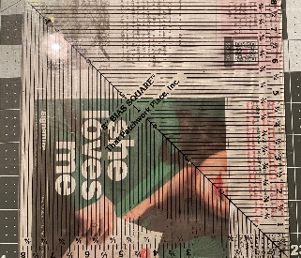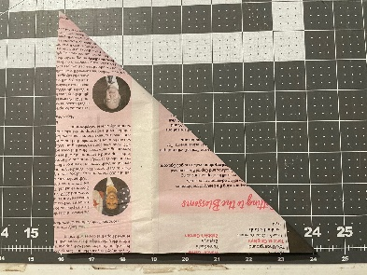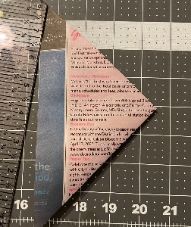
- You may wish to write (with permanent Micron marker), embroider (by hand or machine), cross-stitch or iron on a message for the quilt. It can be done now, before being sewn, or later, when completed. Think about including the name of your club or a nice gardening quote or saying of your choice. If necessary, back the muslin strip with a suitable stabilizer. Be sure to provide for a seam allowance!
- Take the 3” x 13” white muslin center strip of fabric and fold the center line across the 3” and finger press. Open the fabric on the paper, right side up, so the center line of the fabric matches the center line of the paper. The white strip will be on the diagonal of the paper.
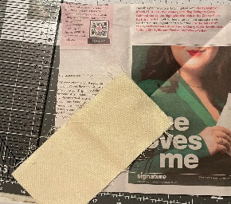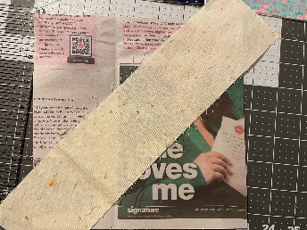
- Cut 8” x 8” piece of 100% cotton fabric. This fabric can be floral, perhaps to reflect the name of your club. It can be your district color. It can be any color. (Try to avoid plaids, strips, overly large and one-way designs. You may wish to “fussy cut” a specific design.
- Cut the 8” x 8” fabric on the diagonal to form two triangles the same size. Please use the same fabric on both sides of the block. Fold in half and finger press the center line.
- With right sides together, line up the center of one triangle with the center of the white fabric on the paper base. Pin in place. Adjust your stitch length to a tighter, shorter stitch length (Do not baste or zig-zag the stitch).
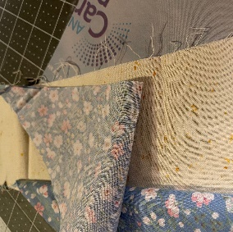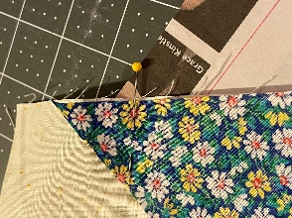
- Sew along the bias edge through all 3 layers (paper, center strip and fabric triangle. Seam should be ¼” or the width of your presser foot toe. Open out and press. Since you are sewing a bias edge, the fabric will have a tendency to bow or stretch. It should press flat.
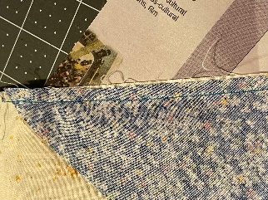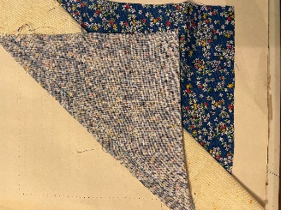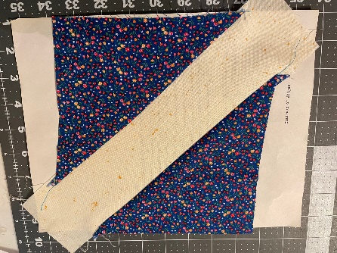
- Take the second fabric triangle and again, fold in half and finger press the center. Match the center fold to the center fold of the center strip now sewn to the paper pattern. With right sides together, pin in place and sew with ¼” seam. Flip open and press.
If you need help, please refer to the photos that have been enlarged and placed on the FFGC.org website or call Tina at 850-587-2361 (h) or 850-341-2361 (c).
DO NOT TRIM THE SQUARE!!!
DO NOT REMOVE the PAPER PATTERN ON THE BACK!!
Return it to Tina Tuttle within the next year and receive your $1 reservation fee back! (You may return it to Tina at the October 2023 District Meeting, send it to FFGC HQ with a member of the Board of Directors, mail it to Tina at 6755 Hwy 99, Molino, FL 32577-4048 or bring it to the 2023 convention in Kissimmee.)
Thank you for participating in creating a beautiful Centennial Quilt! Be sure to purchase an opportunity ticket to win this fabulous creation at convention in Jacksonville in 2024!
