How to perform an Advanced Search to find people in the Directory even if you don’t know their name

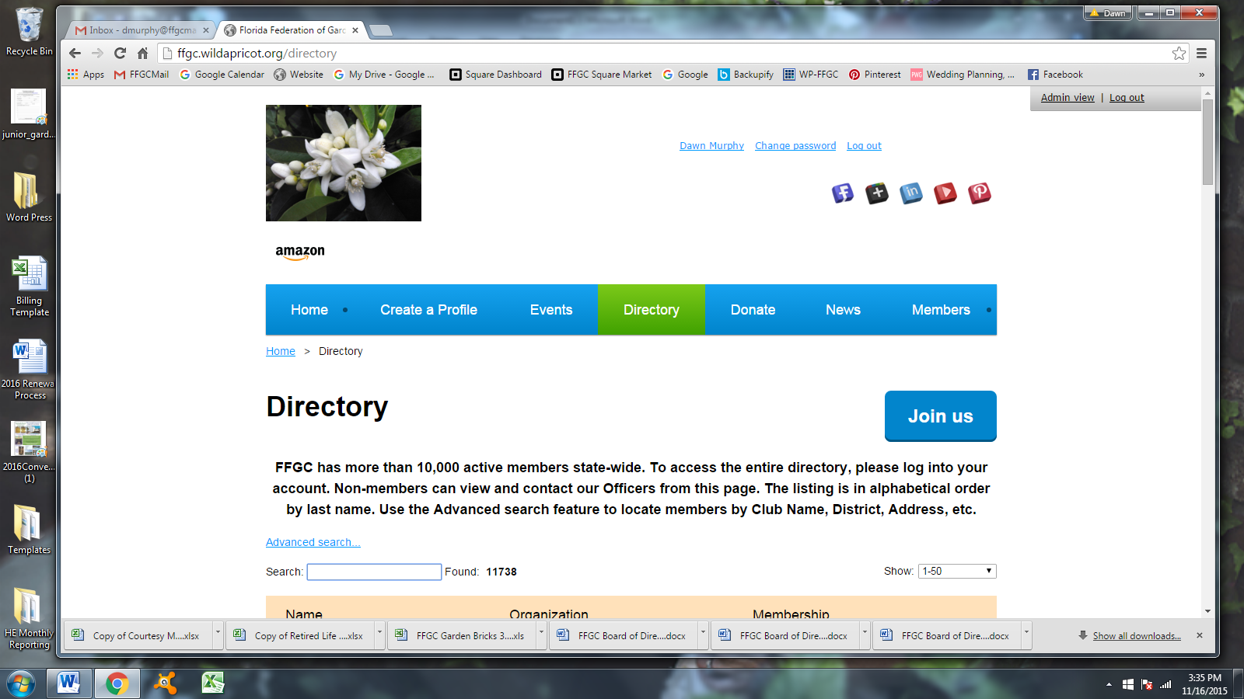

If you don’t know the name of the person or are looking for results of multiple criteria, use Advanced Search

Once you’ve clicked on Advanced Search, a new page will appear offering several criteria for you to choose from. In this example, I’ve clicked the down arrow in the Chairmanship field to display my choices. I’m choosing ‘contains’ and in the next example, I’ll type in the chairmanship title, or a word I think might be in their title. This is how you can find people even when you don’t yet know who they are/what position they hold.

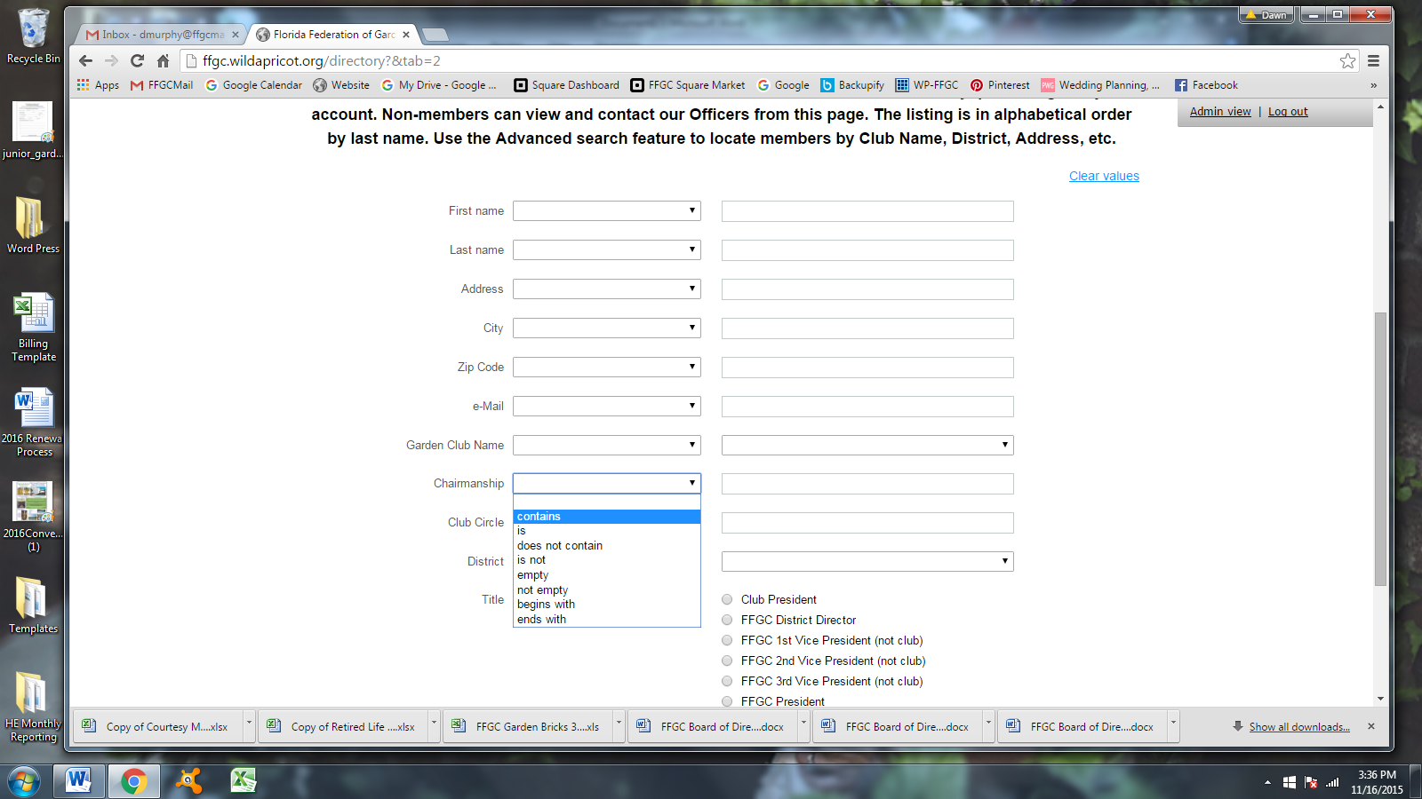

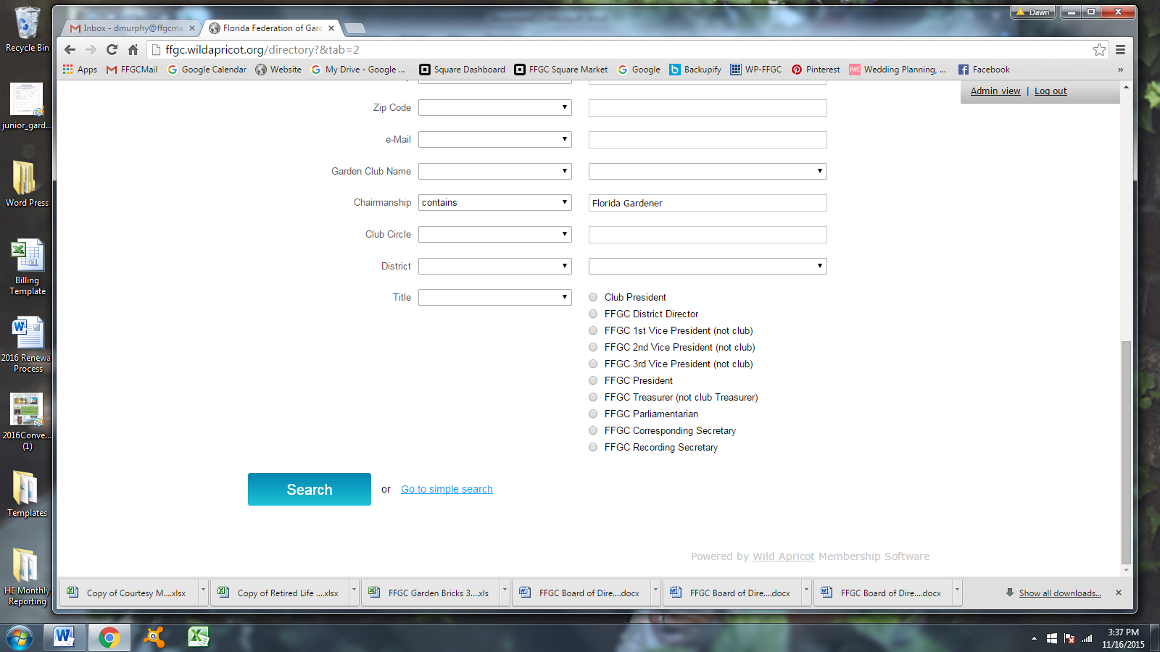

Next, fill in the words or title you’re searching for. It’s just like composing a sentence. ‘Chairmanship – contains – Florida Gardener.

You can search for multiple criteria if you need to such as the chairmanship title and the district or city.

When criteria selection is complete, click on the large blue Search button at the bottom left of the page.

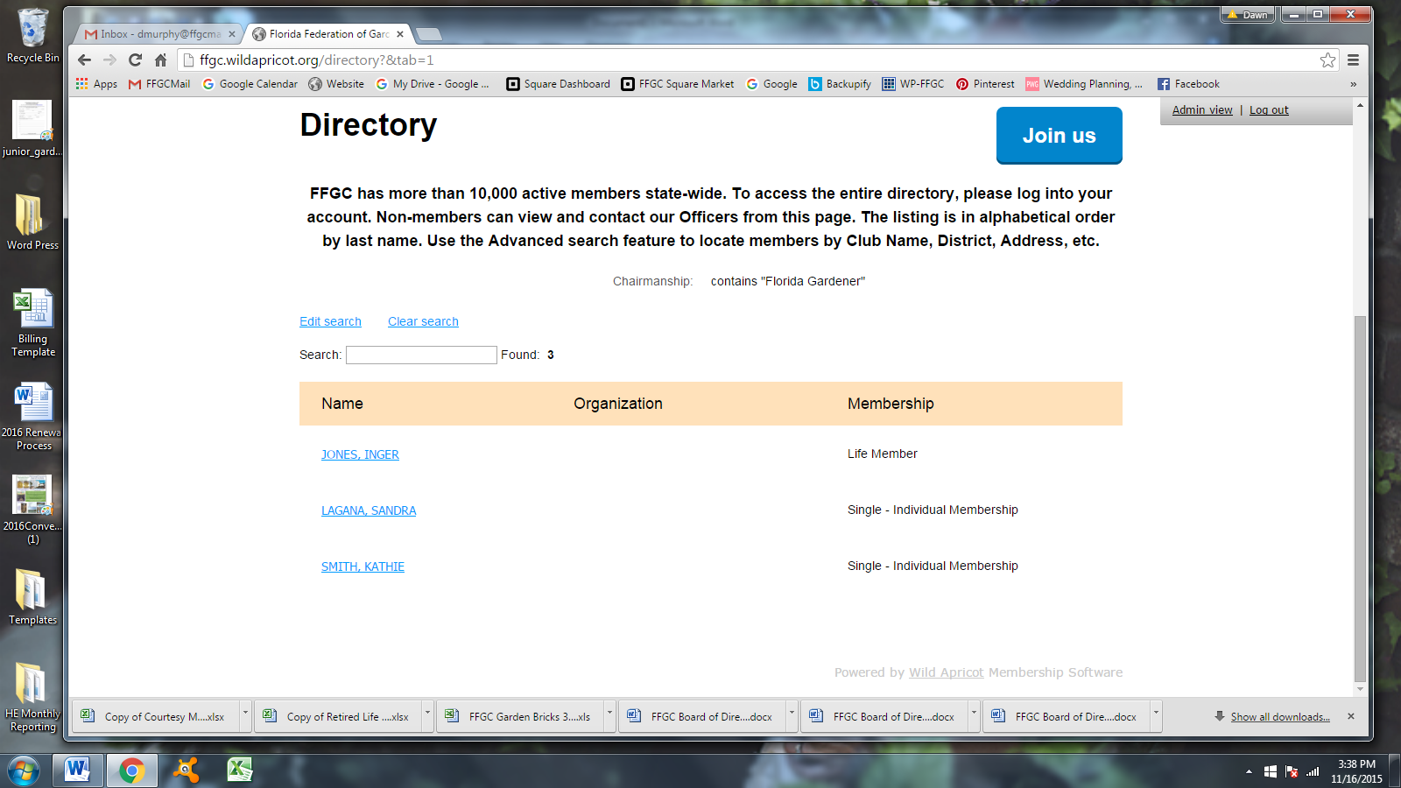

The search results in 3 names. These 3 persons have the words Florida Gardener in their chair title.

Selecting any of the names will take you to their public profile.

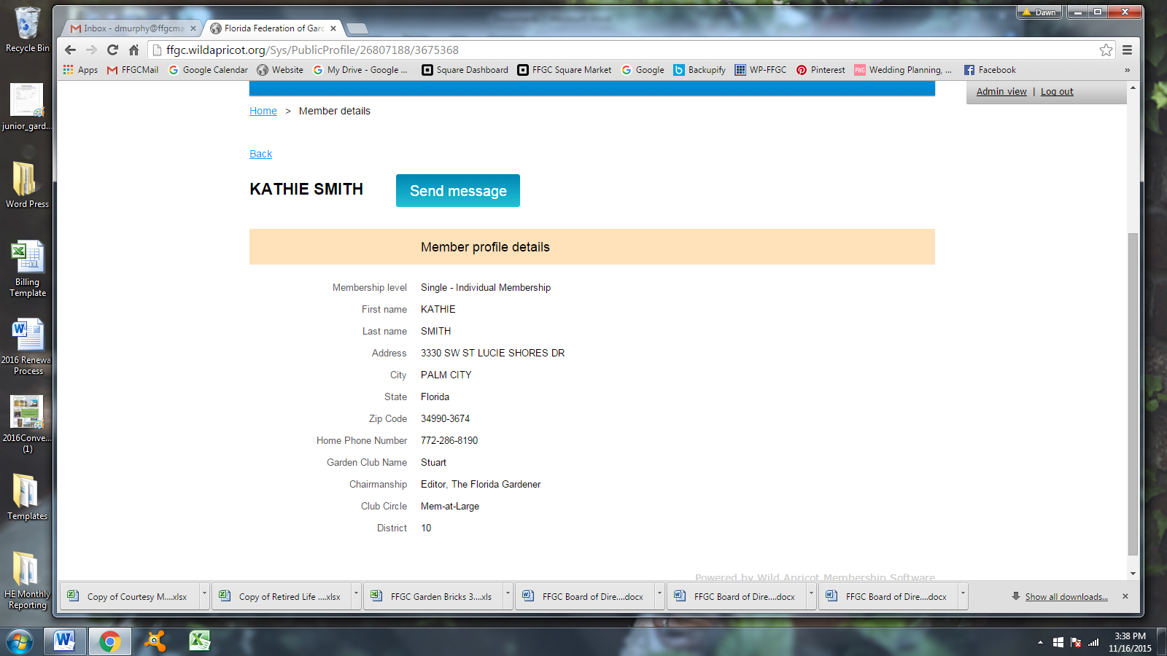

I clicked on Smith, Kathie and the webpage displayed is Kathie’s public profile – her chairmanship is listed as the Editor of the Florida Gardener.

I can click the Send Message button by her name to send an email to her.