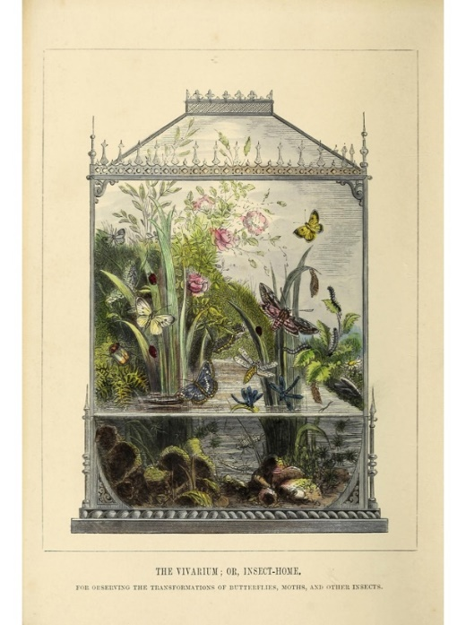

***Summer Short Course***

***Plant The Planet: How Plants Can Save Our World***

**June 2-4, 2024**

*Sponsored by*

***Florida Federation of Garden Clubs, Inc., District V***

***&***

***University of Florida/IFAS***

**For more information: Carol Binello, Event Chair**

**Ffgc.org/Events** [**carolannbinello@gmail.com**](mailto:carolannbinello@gmail.com)

**(352) 215-9190**

Design by Paul Wales, Atlas Screen Printing

and Embroidery