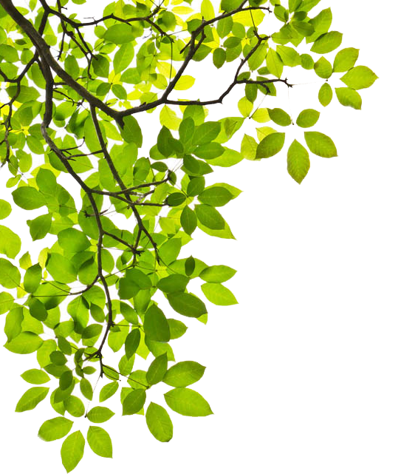
Plant America with Trees
City Proclamation

Whereas, the Earth’s Biosphere is an interconnected living web of life of which humans are part;
Whereas, the Earth’s Biosphere is experiencing an increase of global temperatures, unprecedented levels of habitat destruction, loss of biodiversity, extinction of species, and rising of and lengthening of heat waves;
Whereas, the Earth, our home, is experiencing increases of extreme weather, glacial retreat, loss of sea ice, and increasing sea levels;
Whereas, the Earth’s Biosphere is made up of many smaller living webs of life called habitats;
Whereas, native trees represent the very foundation of most land-based habitats and represent the very lungs of these habitats, restoring life webs, wildlife, watersheds, and living soil;
Whereas, native trees incorporated into the landscape of our yards and communities helps increase the amount of habitat available to our native wildlife displaced by human development and necessary for supporting complex life webs and helps decrease the amount of resources, such as water and chemicals, used in our public lands and in our yards;
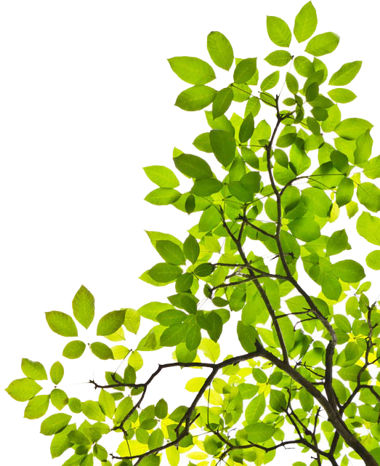
Whereas, native trees stabilize erosion, improve the soil in a way non-natives do not, improve air quality, reduce ozone, cool cities, decrease pollution, prevent runoff, improve human health and living conditions, conserve water, improve local climates, and produce oxygen and absorb carbon dioxide;
Now let it therefore be resolved, _________________________of the City/Town of__________________________________ provides recommendations to local governments, developers and residents regarding landscaping to promote wise restoration and stewardship of local habitats, including the promotion of planting native trees as well as the maintenance of their habitats in urban and suburban settings, dated _________________.

